**Boston Housing Authority**

**Center for Community Engagement and Civil Rights**

**Resident Empowerment Coalition**



**TRAINING MANUAL**   
A guide in building a duly elected local tenant organization



# Center for Community Engagement and Civil Rights

The purpose of the BHA CCECR is to build and support sustainable communities in BHA housing by engaging residents in building capacity and advancement opportunities, broadening access, raising customer service standards, and affirming civil rights.

Resident Empowerment Coalition is a joint resident empowerment initiative launched in 2011 by BHA with residents and housing advocacy groups and is now an integral part of the CCECR. The Resident Empowerment Coalition is designed to strengthening resident engagement through educating and mobilizing residents to support organizing. The main goal of REC is to engage residents in BHA programs, policymaking and community development opportunities.

This manual is being provided by the Boston Housing Authority Center for Community Engagement and Civil Rights Department and the Resident Empowerment Coalition.

The purpose of this manual is to describe a standard process to ensure the legitimacy of the election of officers onto a local tenant organization, also known as a resident council or task force. This manual includes both Federal and State regulations as described in the 964.130 cfr Federal Regulations and 760 cmr State Regulations. The Boston Housing Authority, through its Tenant Participation Policy, has formatted a uniform method of residents electing officers to assure a fair and democratic process that is inclusive and allows the opportunity to all to be part of their local tenant organization. The manual includes regulations for both state and federal developments. The procedures described in this election manual will be written in a way that is easy to understand and this manual will be accessible to all Boston Housing Authority residents.

# Mission Statement

The Boston Housing Authority mission is to provide stable, quality, affordable housing for low and moderate income persons to deliver these services with integrity and mutual accountability and to create healthy living environments which serve as catalyst for the transformation from dependency to economic sufficiency.

# Sugar Sweetened Beverage Policy

**Purchasing Food and Beverages:** Under Memorandum of Agreement Section 4: Permissible Uses of Resident Participation Funds, it allows for “reasonable refreshment and light snack costs that are directly related to resident meetings for activities discussed above and are eligible uses of Resident Participation Funds”.

In addition to the MOA the Boston Housing Authority has added the word Healthy to its Mission Statement and has adopted the **Sugar Sweetened Beverage Policy** which states the following:

*“The BHA has a long history of supporting resident health initiatives and promoting resident health. In recognition that Sugar-Sweetened Beverages (SSBs) can contribute to obesity, tooth decay, heart disease, diabetes and other health issues, it is the BHA’s policy not to purchase SSBs when providing beverages for resident meetings or events. In addition, its policy to provide water as the primary beverage at these forums.*

*Sugar –sweetened beverages (SSB) are drinks with added sugar including: non-diet soft drinks/sodas, flavored juice drinks, sports drinks and energy drinks. This policy does not refer to coffee, tea, or natural juices.”*

For this reason local tenant organizations will not be permitted to use Tenant Participation Funds to purchase SSBs and will be encourage to purchase healthy light refreshments.

# Acknowledgement

The Boston Housing Authority Center for Community Engagement and Civil Rights –Resident Empowerment Coalition is pleased to work with the local tenant organizations and resident leaders in bringing this effort together to increase local tenant organizations across the city. We have developed this manual to help residents, partners and local tenant organizations through the election process.

While some of the information in this manual provides city, state and federal policies our goal is to focus on the election process and procedures.

Many thanks to the Resident Housing Corp Member staff who have provided critical election feedback that we have incorporated into this manual and have help coordinate training to pilot many of the outreach and recruitment materials.

Lastly, we want to acknowledge the hard work of our Language Access team that make it possible for residents who speak and read another language to be able to participate in the trainings by providing translation and interpretation of all outreach material, interpretation at meetings and outreach support to allow true resident engagement.

We appreciate your enthusiasm, leadership and trust in us and we are excited by this partnership with you. Please do not hesitate to contact us if you have any questions about the information in this manual.

Thank you for your support.

**Contact Information**

Resident Capacity Program

40 Bickford Street, Second Floor

Jamaica Plain, MA 02130

|  |  |
| --- | --- |
| Table of Contents | Page (s) |
| Introduction | 2-4 |
| Overview of a local tenant organization | 7-9 |
| * Your right to organize | 9-10 |
| * Role of Boston Housing Authority Supporting a local tenant organization | 11 |
| * Formation of a local tenant organization/requirements | 11-12 |
| Step by Step Election Process | 13 |
| * Step One: Petition for a new election process | 16 |
| * Hosting the community meeting | 16-20 |
| * Step Two: Setting up the election committee | 21-24 |
| * Step Three: Designing the nomination form with requirements and deadline | 25-31 |
| * Step Four: Outreach and recruitment | 32-35 |
| * Step Five: Hosting a candidates event | 36-38 |
| * Step Six Find a poll monitor | 39-41 |
| * Step Seven Hosting Election Day | 42-49 |
| * Step Eight Obtaining recognition | 50-59 |
| * Step Nine By Laws-Formation of by laws | 60-76 |
| Attachments |  |
| Sample Letter/Petition to request an election process | 18 |
| Sample leaflet for community meeting | 19 |
| Sample Confirmation letter of understanding | 20 |
| Advisory Committee Agreement | 24 |
| Sample Nomination Form (for election of specific officers) | 28 |
| Sample Nomination Form (for election of board members) | 29 |
| Sample instructions to fill out a nomination form | 30 |
| Sample Good Standing Policy | 31 |
| Election Work Plan | 35 |
| Sample Ballot | 46-47 |
| Sample Letter of Independent Third Party | 48 |
| Sample Letter of Election Committee | 49 |
| Sample Local Tenant Organization Checklist | 52 |
| Sample Letter of Agreement for Arbitration | 53 |
| Sample Letter for Request for Recognition | 54 |
| Sample Report of Election Committee Members | 56 |
| Sample Tally for each Candidate | 57 |
| Sample of Elected Board Members Name and Contact Information | 58 |
| Sample Expected Meetings Dates of Board | 59 |
| Requesting an Election Extension | 63-66 |
| By Law Template | 67-76 |
| Disclaimer | 77 |

# Overview

**What is a local tenant organization and your rights to organize?**



Overview of a local tenant organization 

### What is a local tenant organization?

A local tenant organization (also known as tenant organization, resident council, and/or task force) consists of tenants who live in a certain building or public housing development, or scattered sites managed by the same housing authority or landlord.

### Purpose of a local tenant organization:

The purpose of forming a local tenant organization is but not limited to:

* Informing tenants of their rights under local, state, and federal law.
* Organizing and lobbying on behalf of tenants and tenants' rights, especially at city and county levels of government.
* Improving tenant-landlord relationships, building conditions, and services for tenants through organizing and negotiating efforts.
* Encouraging regular communication and community awareness among tenants.
* Advocating for onsite or offsite social, educational and recreational programs.
* Advocacy for the prevention or intervention of tenant eviction.
* If able, organizing fun activities on or off the site.
* Knowledge and participation in development and understanding of polices such as rent recertification process, grievance rights, lease, etc.

Example: The local tenant organization has identified the need to improve the landscape of their development to motivate tenants and visitors to maintain their property clean and healthy and encourage proper disposal of trash.

|  |  |  |  |
| --- | --- | --- | --- |
| Need | LTO Role | Management Role | Community’s Role |
| Beautification of landscape | Meet with residents to get support and assess interest and support from residents either by survey or a community meeting | Meet with LTO and residents to discuss what support they could provide such as a change in the budget, provide equipment for gardening program, set a community clean- up day, etc. | Support the residents through funding, volunteering or equipment. |

## Your Right to Organize

The federal Department of Housing and Urban Development (also known as HUD) and the state Department of Housing and Community Development (also known as DHCD) recognizes the right of tenants who live in public housing, Section 8 and other subsidize housing to organize. More importantly they encourage tenant participation in any decision making processes that will improve resident and management relationships and the quality of living which includes but not limited to:

* Creation or change of policy particularly ones that affect your lease agreement and rent.
* Changes in living conditions such as renovations.
* Improvements in living conditions such as fixing code violations and safety and security.

HUD regulations state the following for tenant participation:

§ 964.1 Purpose.

The purpose of this part is to recognize the importance of resident involvement in creating a positive living environment and in actively participating in the overall mission of public housing.

For full copy of this policy go to [www.hud.gov](http://www.hud.gov/)

DHCD regulations state the following for tenant participation:

6.09: Tenant Participation

1. Purpose. Participation by tenants and household members through effective tenant organizations is beneficial to the administration of public housing. Cooperative working relationships enhance housing programs and benefit both LHAs and residents. The purpose of this subsection is to encourage the formation of representative organizations and to provide such organizations with the opportunity to be heard on and **participate in matters affecting the interests of the residents** [**www.mass.gov/dhcd**](http://www.mass.gov/dhcd)

Under the federal and state regulations your public housing or management are prohibited from taking negative action solely based on a tenants participation or membership in their local or citywide tenant. Examples of prohibited management conduct include:

* Sudden rent increases (does not include increase in rent during rent recertification due to an increase in household income reported).
* Refusal to make necessary repairs.
* Entering your apartment without proper and timely notification.
* Threats of eviction (does not exclude management from seeking eviction due to lease violation).
* Prohibiting tenants from organizing community meetings.

Preventing use of space for meetings in common areas on the building's premises if other groups are allowed to do so.

### Why have a duly elected local tenant organization?

Local tenant Organizations help bridge relationships between neighbors, their management office, and their surrounding communities. It is important to have a duly elected LTO to maintain what is working or bring about changes and improvements such as:

1. Build relationship with Boston Housing authority management and other departments (adversarial vs collaboratively). Work closely with management to help promote changes in the community such as creating building captains to improve safety in buildings.
2. Grass root organizing: Building support among the public for social change or to prevent change such as prevention of unfair evictions. Organize residents at their development leveraged changes at the legislature, in the courts, in the economic system, or other areas of society. It is developing awareness of an issue among large numbers of people in order to support an action.
3. Build relationships and strong collaborations with local business and service providers to meet the needs of the resident at your development or public housing in general.

# Role of BHA supporting local tenant organizations

The Boston Housing Authority has developed their Tenant Participation Policy which describes the type of relationship BHA is required to have with local tenant organization, requirements of LTOs to maintain recognition or acquire recognition, and election process requirements. To obtain a copy of the Tenant Participation policy go to [www.bostonhousing.org](http://www.bostonhousing.org) or email [REC@bostonhousing.org](mailto:REC@bostonhousing.org). More will be discussed in the following chapters on what support BHA is required to give.

## Formation of a Local Tenant Organization

Whether you are forming a new local tenant organization or re-electing current or new members onto an existing local tenant organization, federal and state polices require the minimum procedures.

Residents should request their local housing authority to assist them in the formation of the organization and review The Boston Housing Authority Tenant Participation Policy requirements and their own bylaws (if applicable). At a minimum it is required that residents:

1. Inform the BHA in writing about your interest to form a local tenant organization.
2. Form an election committee that will oversee the election process that consist of no less than three members who live in the development or have an interest in seeing the success in the development.
3. All voting members (made up of head of household and household members over the age of 18 and on the lease) must be given sufficient notice (at least 30 days) for nomination and election.
4. The notice should include a description of election procedures, eligibility requirements and due dates of nominations and elections.
5. All notices must be translated in English and two other most spoken languages at that development.
6. An informational community meeting must be held at the beginning of the election process to allow qualifying tenants to ask any questions or state concerns.
7. Must have no less than five qualifying candidates to proceed with elections (or whatever number your bylaws indicate).
8. Must host a Candidates Event to introduce candidates to the larger membership (other tenants).
9. Elections must be overseen by a third party arbitrator.
10. A final report detailing the election process must be submitted to the BHA by the election committee and the third party arbitrator in order to receive recognition.
11. If you are a recognized local tenant organizations you are mandated under state and federal regulations to create written procedures such as bylaws* which provides for the election of tenants to the local tenant organizations by the voting membership of the tenants residing in the public housing development. It must include.

* The regular basis in which elections will be held (no less than every three (3) years).
* The written procedures must provide for the recall of the local tenant organization by the voting membership.
* The procedure should allow for a petition or other expression of the voting membership's desire for a recall election, (no less than 10% of the voting membership).



**STEP BY STEP ELECTION PROCESS**



**1**

**Step One**

HOSTING THE

COMMUNITY MEETING

# ICEBREAKER:

Two truths and one lie

Each one of you will get a piece of paper. On that piece of paper write down three (3) things about yourselves which may not be known to the group. Two of those things must be true and one of them must not be true. The group will have to guess which one is not true.

Notes___________________________________________________________________________________________________________________________________________________________________________________________________________________________________________________________________________________________________________________________________________________________________________________________________________________________________________________________________________________________________________________________________________________________________________________________________________________________________________

# STEP ONE: Petition for a new election or complying with bylaws

Under the 964 Regulations recognized local tenant organization are required to have elections at a minimum every three years or whatever is specified in the bylaws. If no local tenant organization exists, residents at a development may request assistance to develop an LTO through a written petition to the Boston Housing Authority. (See sample on page 18)

## HOSTING THE COMMUNITY MEETING

Hosting a community meeting is a great way to exchange ideas and information. In an active meeting resources are shared and volunteers can be recruited. You should follow these few basic steps

1. Plan your meeting one month ahead of time this will allow you to design and distribute a leaflet to participants as well as to secure a meeting place.
2. Designate responsibility to each person such as; who is going to be responsible for getting the space, who is going to make the leaflet, who is passing it out, who is going to plan the agenda and copy it, etc.
3. Make sure you set the meeting at a time where the majority of tenants are available. If the majority of tenants worked 9am-5pm, then having it in the evening or weekend makes better sense.
4. Make sure it is at a location that is accessible and known by everyone. For instance don’t have it on the third floor that doesn’t have an elevator or three blocks away from the development.
5. Send out a reminder notice two days ahead of time. Many people forget and need a second reminder.
6. Don’t make the leaflet to wordy and use everyday language.
7. Leave your contact information on the leaflet.

During the meeting:

* Arrive no less than 30 minutes early to set-up.
* Make sure to start on time and stick to the agenda.
* Make it interactive have an icebreaker at the beginning of the meeting.
* Make sure you have a sign in sheet which allows individual to leave their contact information.
* If possible have healthy snacks.
* If you are using a power point presentation or hand-outs make sure you look up. There is nothing worse than reading out to the audience it makes you look unsure of what you are talking about and bores them.
* Make sure you leave time for questions and answers.
* Don’t forget to ask for volunteers for the Election Committee which is mandatory to have.

In some cases there can be the opportunity to become part of an ongoing community meeting that are usually standardize at a particular development. This normally happens when you have an already recognized local tenant organization or a management that host standard meetings with their tenants. If this is the case you can request to be part of their monthly community meeting. Just be prepared to have less time and leave your contact information.

*See Sample Community Leaflet on page 19)

|  |  |  |  |
| --- | --- | --- | --- |
| Cultural Sensitivity and Practices | There are several things to consider in trying to get people to participate. When reaching out to people consider their practices and community cultural practices | | |
| Languages |  |  |  |
| Sub-culture |  |  |  |
| Common Practices in the community |  |  |  |
| Availability |  |  |  |
| Personal needs |  |  |  |
| Other |  |  |  |

Sample Letter for Petition for Support for an Election Process

Date:

Kenzie Bok

BHA Administrator

52 Chauncy Street 11th Floor

Boston, MA 02111

Dear Ms. Kenzie Bok,

We the undersign, faithfully submit this petition for request for assistance and permission to host an election process for the local tenant organization as described under the Boston Housing Authority “Tenant Participation Policy”

Should you have any questions you may contact xx at 617-xxx-XXXX. We thank you for your assistance

Place signatures below:

Send to:

Boston Housing Authority

Resident Capacity Program / Resident Leadership & Community Affairs

40 Bickford Street, Second Floor

Jamaica Plain, MA 02130

[REC@bostonhousing.org](mailto:REC@bostonhousing.org)

**Sample Attachment Community Meeting**

It’s that time of year

The Spring Street Tenant Task Force Elections Are Coming Up

Join us at a Community Meeting to learn more on how you can join!!

Tuesday, September 13, 2016

12:00pm

Spring Street Community Room

———————————-

La Hora de la Elecciones de

La Asociacion de Inquilinos de Spring Street Se Acerca

Únase con nosotros en una reunión comunitaria para aprender más sobre cómo puede unirse a la asociacion de inquilinos !!

Martes, Septiembre 13, 2016

12:00pm

Salon de la Comunidad de Spring Street

**Sample Confirmation Letter of Understanding**

The letter should confirm the understanding of the Tenant Participation Policy ( or at least a general understanding of what is a local tenant organization election for public housing) and confirmation that the election committee, vendor and third party will abide by the policy, Resident Capacity Program Coordinator at 40 Bickford Street Second Floor, Jamaica Plain, MA 02130 or email at [REC@bostonhousing.org](mailto:REC@bostonhousing.org)

Sample:

Date: xx/xx/xxxx

Kenzie Bok

Administrator

Boston Housing Authority

52 Chauncy Street 11th Floor

Boston, MA 02111

Dear Ms. Bok,

This letter is to confirm that the election process for the (Development Name) local tenant organization elections will be ran in accordance with the Boston Housing Authority Tenant Participation Policy and the Federal Regulations CFR 964 Tenant Participation or State Regulations 760 CMR of recognition of local tenant organizations (LTOs) also known as task forces, tenant organizations and resident councils.

CC Resident Capacity Program Staff



**STEP TWO**

SETTING UP THE

COMMUNITY MEETING

# Group Activity:

*Answer these three questions:*

* What type of individual would you want to help you organize and election process?
* What should they know about your community?
* What support can you give them?

# STEP TWO: SETTING UP THE ELECTION COMMITTEE

**Having residents join the Election Committee is a very important part of the election process. It is required under the BHA Tenant Participation Policy:**

1. Election Procedures

8.3 Prior to each regular or recall election, the LTO Board shall establish and select an Election Committee (recommended minimum of three members) comprised of LTO Members who are not candidates and/or volunteers who are not LTO Members, and shall seek inclusion on the basis of race, color, national origin, religion, gender, sexual orientation, age, familial status, and disability. The Election Committee shall implement and conduct all LTO election activities as well as ensure the LTO’s compliance with all election requirements. The LTO shall not have elections if no Election Committee is established.

**To be an Election Committee member you must be a tenant of your development or an individual who holds the best interest of the residents living at that development and over the age of 18 years old.**

As an Election Committee member you will help with the following:

1. Plan for fun events that help to get your neighbors out to participate in the elections.
2. Familiarize yourself with the bylaws and BHA Tenant Participation Policy.
3. Design the materials that will be used in the elections, including the nomination form.
4. Ensure that all residents who are running for election comply with all the election requirements as described in the bylaws and Tenant Participation Policy.
5. Setting up for Election Day.

See sample agreement form for election committee on page 24

|  |  |  |  |
| --- | --- | --- | --- |
| Activity | It is often difficult to find people to serve on the election committee. Think about it more broadly. Who is part of your community that can possibly be part of the election committee. | | |
| Service Providers |  |  |  |
| Vendors |  |  |  |
| Who identify as a leader |  |  |  |
| Church Groups |  |  |  |
| others |  |  |  |

**Election Advisory Committee (EAC)**

**Purpose, Term, and Commitment Agreement**

The purpose of the Election Advisory Committee is to work independently of the current local tenant organization and when called upon work jointly with the staff of the third party vendor to assure a fair and democratic election process. Members of the EAC are to proceed with the election process without prejudice, bias or discrimination against members of the current local tenant organization, possible candidates or any other tenant of the community.

Recruitment of the EAC can be done during the community meeting and the request for membership through the initial mailing, if any. EAC members must be recruited from the general membership *(tenants who live in the development where elections are being conducted),* public housing tenants from other developments, or individuals who have an interest in improving the quality of life for tenants at that particular development such as, tenants living around the development (non-public housing neighbors), service providers who provide programs and have an investment in that community.

The Election Advisory Committee

* Is an unpaid, volunteer position
* Helps identify potential candidates
* Encourage tenants to fill out nomination forms and pass them in before the deadline
* Works independently from the local tenant organization (if any)

Activities they must host

1. Review the bylaws (if any) with regard to the election process
2. Community Meeting
3. Decide on the election process including the following:
   * Date and location for the election
   * Qualification of candidates (if not done before the community meeting)
   * Content of the nomination papers (if not done before the community meeting)
   * Time and location of Candidate Event
   * Strategies for recruitment and outreaching
   * Absentee ballot system
   * Process for counting ballots, including designating people to do the actual count

I, _________________________________ living at _____________________________

Wish to become a member of the Election Advisory Committee for the (**development** name here local tenant organization election process). I agree to the above terms and conditions (within reason, skills I can contribute and as my schedule permits) and fully understand the importance of becoming an election advisory committee member. I understand that my contribution is solely for the benefit of supporting the tenants of (name of development) in order to strengthen the relationship between tenants, the Boston Housing Authority, and other interested parties to improve the quality of life for all the (name of development tenants). I understand this is an unpaid, temporary position, which might require me to volunteer some hours during the morning, afternoon, evening and weekends as my schedule permits

Signature ___________________________ Date ___________________

Phone number _______________________________________________

Available Hours

|  |  |  |  |  |  |  |
| --- | --- | --- | --- | --- | --- | --- |
| Day | Monday | Tuesday | Wednesday | Thursday | Friday | Saturday |
| Time Available |  |  |  |  |  |  |
|  |  |  |  |  |  |  |

**3**



**STEP THREE**

DESIGNING THE NOMINATION FORM WITH REQUIREMENTS AND DEADLINE

# Group Activity:

Answer these questions:

* What would attract you to open up your mail and actually read it?
* What would motivate you to consider being on board?

# STEP THREE: DESIGNING THE NOMINATION FORM WITH REQUIREMENTS AND DEADLINE

What is a nomination form? A nomination form is a written document used to select someone for a particular job, election or to honor. It is a standard form for nominating (different than electing) a person into the board of directors. Nomination forms to sign off on by those who want to nominate a person to represent their best interest. The purpose of filling out a nomination form is to get permission from those you wish to represent. You are basically getting permission to be elected to represent their needs, speak out on their behalf and inform them about opportunities. The Tenant Participation Policy requires that the nomination form has the following:

1. Identify who qualifies to be a candidate.
2. Timeline, including deadline for when to gather the resident signatures and by when to submit it.
3. Where and to whom the nomination form must be submitted to.
4. Process to which they will be held to for example, only those on the lease can run and they must be over the age of 18 years old.

See sample nomination form on page 28

## Who qualifies to be a candidate?

The BHA Tenant Participation Policy clearly identifies who qualifies to be on their tenant organization. The rules are the same whether you live in State, Federal, Family or Elderly/disable developments. The common qualification are:

1. Must be a BHA resident and living at the development where the elections are happening. For example, you can only run to be on the local tenant organization at Amory if you are live at Amory and cannot serve on the board of another LTO at any development.
2. Your name must be on the lease. In some cases personal care attendants reside with the head of household but do not qualify to run since they are not on the lease, they only reside in the household for the purpose of taking care of an individual authorize by the BHA
3. You must be 18 y ears old or older, in some cases if bylaws permit, individuals under the age of 18 who are head of household may qualify
4. You must be a resident in “good standing” which means there are no lease violations (please see attached good standing policy on pages 31).
5. You must collect the number of required signatures that vary from development to development and submit nomination form with signature before the deadline and to the proper office.

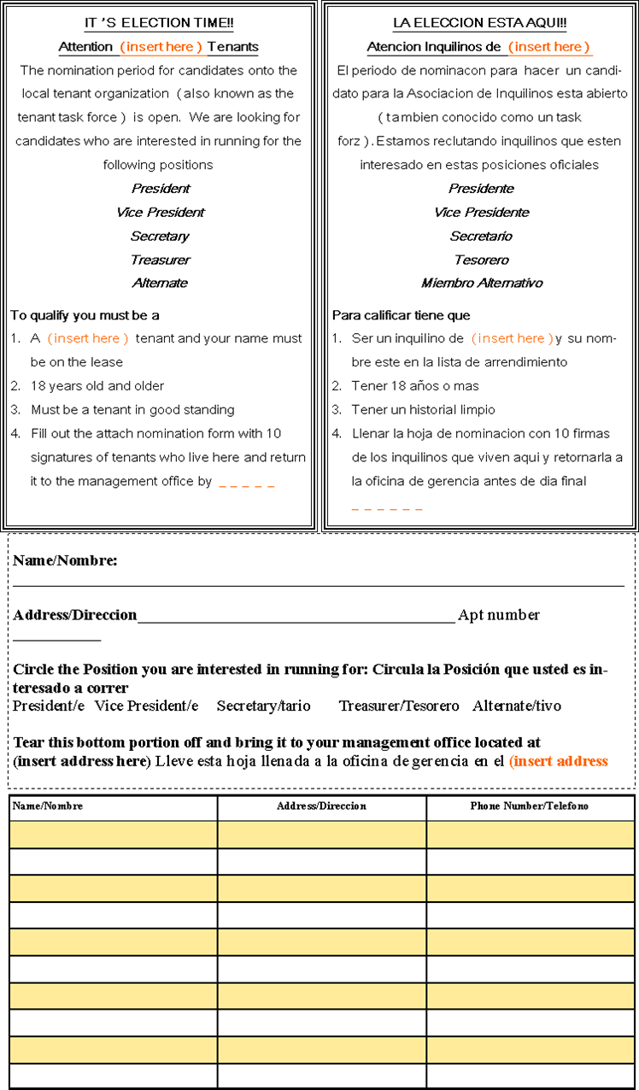

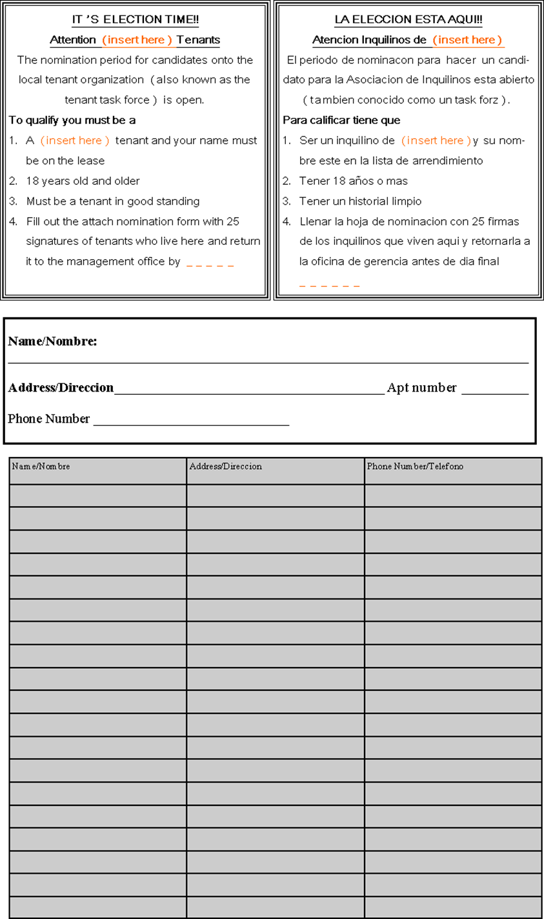

**Sample Instructions to fill out the Nomination Form**

**Who Can Join the Tenant Organization?**

Any Resident of the (name of the development who is over 18 years old, or if under the 18 years old must be head of household. You must be in Good Standing. You do not have to be a citizen

**What do I have to do to join?**

1. First, fill out the nomination paper with you name, address and phone number
2. Second, you must get **xx** number of signatures from other tenants who are 18 years old or older and they must be on the lease
3. Third, once you get all of your signatures, take your nomination paper to the management office leave it in the box marked Election Box on or before the pre-deadline which is **XX/XX/20XX** at (address of management office here).Deadline for all nomination forms are **XX/XX/20XX**
4. Fourth, once your nomination paper has been reviewed, someone from the election committee will notify you if you have met all of the requirement or if you need to get more signatures before the deadline to become a candidate. Deadline submission of nomination form is **XX/XX/20XX.**
5. Fifth, once you have been notified you are a candidate, we will help you prepare for Candidates Night and help you prepare for campaigning and Election Day.

**Quien puede unirse a la Asociación de Inquilinos?**

Cualquier inquilino de (nombre de vecindario) que tenga 18 años o más y debe de tenar un historial limpio. No tiene que ser ciudadano.

**Que hago para unirme?**

1. Primero, llene la hoja de nominación con su nombre, dirección y número de teléfono.
2. Segundo obtenga XX firmas de inquilino que tengan 18 años o más y tienen que estar en la lista de arrendamiento para poder firmar.
3. Tercero, cuando obtenga todas sus firmas, lleve su hoja de nominación a la oficina de gerencia en el (Management address) y déjela en el buzón marcado Elección Box antes o en el día de pre-sumisión **XX/XX/20XX.** El último día para retornar su hoja de nominación es **XX/XX/20XX**

**Good Standing/Lease Compliant**

**For Purposes of Ability to Serve on the Board of a Local Tenant Organization (LTO)**

**September 10, 2012**

1. The Boston Housing Authority’s Tenant Participation Policy states that: “Any LTO Member who meets the requirements described in the Bylaws and is in **good standing** with the BHA may seek and serve on the LTO Board.” (Section 7.2)
2. Good standing means that a resident is “in compliance with the lease” as provided in federal regulations (24 CFR 964.125). It reflects that there may be situations where compliance is being determined or resolved and that until it is determined or resolved, a tenant should be considered in good standing by BHA.
3. A Boston Housing Authority public housing tenant or Section 8 participant household shall be considered to be “in good standing”, or ”in compliance with the lease” for the purposes of eligibility to run for the Board of a local tenant organization (LTO), *except where* BHA, the mixed finance owner, or the private manager:
   1. Has issued a notice to quit for a lease violation (including nonpayment of rent) or a notice of proposed termination of assistance to the tenant’s household which has not been withdrawn, and

b. There is no court decision in the tenant’s favor or there is no court or out-of-court written agreement permitting the tenant to stay and reinstate the tenancy on certain terms and conditions (including a repayment agreement).

4. If the tenant has disputed the termination of tenancy or termination of assistance and the matter is still being reviewed through an informal hearing, a grievance process, or an administrative or court process, the tenant should not be denied the right to run for office unless and until the administrative or court process is completed and the final result is against the tenant.

5. If the reason for termination of the tenancy or assistance was nonpayment of rent, and the tenant has cured the violation (is at zero balance) prior to any court answer date or hearing, it shall not be necessary for the tenant to have a written notice of withdrawal or agreement to be eligible.

6. In a development with tax credits, lack of eligible tax credit status shall not be a basis for denial of good standing, as long as the tenant is willing to transfer to a non-tax credit unit and there are such units available in the development.

7. If BHA determines that a person is ineligible to run for an LTO Board, it shall notify the person of his or her right to dispute this through the grievance procedure, and must include in the notice any deadline for the submission of a written grievance request., as well as a list of agencies that may be able to assist the person with the dispute.

4

**STEP FOUR**

OUtREACH AND RECRUITMENT

# Something to think about when motivating people

**1. Myth #1 -- "I can’t motivate people"**

You can’t motivate people unless they motivate themselves. People gravitate towards people who are friendly and inspiring. If you are humble and real people will be willing to listen to you.

**2. Myth #2 -- "Money is a good motivator"**

Not really. It can make people show up to a meeting or event, but it will not keep them interested. You must find a connection to them. What is important to them and how does it tie in to the elections.

**3. Myth #3 -- "Fear is a damn good motivator"**

Fear is a great motivator -- for a very short time. A lot of yelling will only make people run away or if the participate it will be temporarily. Nobody wants to work in an “angry environment”.

**4. Myth #4 -- "I know what motivates me, so I know what motivates others"**

Not really. Different people are motivated by different things. People might be at different points in their lives. A young couple might be motivated by having a secure jobs and a place for their children to grow up. An elderly person might be motivated by the idea of having a safe and healthy place to spend their time free of children. Figuring out what is important to the individuals in your community is important in motivating them.

STEP FOUR: OUTREACH AND RECRUITMENT

It is the responsibility of the election committee to come up with an outreach and recruitment plan and to assure to the best of their ability each and every qualifying resident gets the information in a timely manner and conduct the election in a fair, democratic, just manner. Here are some sample steps you may take

1. Keep in constant communication with management since they will be playing role in reviewing the nomination forms.
2. Invite residents to the community meeting to participate in planning of the elections. Use community newsletters, newspapers, posters, and e-mail. Allow resident the opportunity to give input on what they would like to see, this helps to build support for future events you will set up.
3. Organize community events such as coffee hour, if residents don’t understand the process they can come and ask questions. Invite speakers if needed such as the BHA CCECR staff to provide training or information.
4. Use as many communication outlets as you have available to publicize events and send information Use websites and online social media, newsletters for your area.. Use social media such as Facebook or Twitter to get the word out. Post notices of meetings and special events in public spaces (with permission), such as libraries, schools, post offices and local stores. Mail flyers to residents as needed.

In addition, the election committee should set up a work plan that could help remind them of what needs to be completed and to keep on time. (See sample work plan on page 35)



|  |  |
| --- | --- |
| **Election Work Plan Sample**  **Election Committee will meet once a week, every __________ from _______ in the ____________.**  **Goal: The Election Committee will recruit no less than six diverse people, reflective of the tenants living at the (name of development) for the five member board onto the (Name of the tenant task force)** | |
| Host Community Meeting to educate tenants on what a task force is as well as roles and responsibilities |  |
| Create Nomination Forms and educational fact sheet |  |
| Have all election materials translated, copied and ready for distribution |  |
| Distribute materials door-to-door |  |
| Conduct door-to-door knocking, recruitment, education and encourage tenants to submit their nominations forms (will recruit no less than 6 candidates) |  |
| Meet with Candidates to plan candidates night and create campaign materials |  |
| Host Candidate Events |  |
| Create Ballot and Absentee Ballot process and distribute reminder notice of Election Day |  |
| Host Election Day and Count Ballots |  |
| Post-Election Results |  |
| Send Report to BHA 10 business day after Elections |  |

5

**STEP FIVE**

HOSTING CANDIDATES’ EVENT

# Something to think about:

Organizing a fun and social event is a must. Stay away from scary words such as Meetings when planning your Candidates night. Use social words such as Coffee Hour, Chew and Chat Event, Family and Friend Social Hours, etc.

Think about what other key words or types of events can motivate people to come out and meet the candidate:

**______________________________________________**

**______________________________________________**

**______________________________________________**

**______________________________________________**

# STEP FIVE: HOSTING CANDIDATES’ EVENT

The Tenant Participation Policy requires that residents have the opportunity to meet with and be granted the opportunity to ask questions of those individuals who are interested in representing their needs.

Before setting up a candidates’ event the election committee must make sure they have the required number of candidates to continue moving forward with the election process and setting up a Candidates Event. To do this they must:

1. Send out a reminder deadline notice out to each household or post it in common places to remind those interested in running to be a candidate to submit their nomination forms before the deadline.
2. Check in with management periodically to make sure people are turning in nomination forms
3. Check in with management after the deadline to make sure they have sufficient candidates to host an election and to get the nomination forms of those who qualified.
4. For those who did not qualify, only the management office is authorize to contact them, not the election committee and their information will not be shared with the election committee.

**Once the election committee verifies there are the sufficient number of candidates as required in the bylaws and/or Federal/State mandates then an event should be plan out. The following steps should take place:**

1. All qualifying candidates must be notified in writing that they qualified. (See attach sample letter) and a meeting should be convene with them to plan out the candidates event.
2. An invitation notice should go out to all household and/or placed in common places for people to see.
3. All candidates are required to attend the candidates’ event.

The Election Committee and the candidates can be as creative as possible in setting up a Candidates Event. They must assure that any event they set up reaches the maximum amount of people. Some examples of Candidates Event can include Coffee Hours with the Candidates, Hot Dog Night with the Candidates, Meet the Candidates at Fair Food Pick-Up, and/or Social Hour with the Candidates.

**Setting up for Candidates Night:** The event should be set up so that residents have the opportunity to speak with the candidates and be able to ask them questions or make recommendations. For example, if you are having a Social Hour with the Candidates, then the residents should be able to walk in, be able to identify the candidates, and ask interact with them. Those event which do not allow for one on one interaction should not be considered.

6

**STEP SIX**

FIND A POLL MONITOR

# Just for your knowledge

Election Inspectors (poll workers) duties can include: issuing ballots to voters, checking off the votes on the list, monitoring the voting equipment, explaining how to mark the ballot, and delivering absentee ballots.



# STEP SIX: FIND A POLL MONITOR

Under the Tenant Participation Policy and many of the LTOs bylaws require that the election secure a third party poll monitor to conduct the poll monitoring, including giving out the ballot, delivering the poll absentee ballots and recording the number of ballots and votes for each candidate . It is define as the following in the Tenant Participation Policy.

*8.6 The Election Committee shall choose an independent third party to observe elections and provide advice as needed. Independent third parties shall be defined as established organizations with relevant experience in overseeing elections, and may include but are not limited to election boards, commissions, community groups, and nonprofit organizations. Upon request by the LTO, the BHA may offer assistance to the Election Committee in choosing an independent third party*.

Who can be my poll monitor?

1. Those who have experience in conducting poll monitoring and have a clear understanding of the rules and regulations
2. Those who are not candidates
3. Those who are not current local tenant organization members
4. Local tenant organization members who serve on the board at another development where the election are not taking place
5. Staff from non-profit agencies who understand the rules and regulations

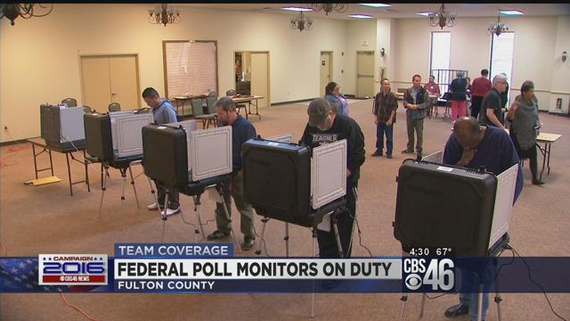

**7**

**STEP SEVEN**

HOSTING ELECTION DAY

# Something to think about

**Make it Personal**

Voters respond better to people they know like friends, neighbors, and community-based agencies that are familiar and trusted. Don’t make the paper handout the main outreach

**Make it Easy**

Voters can let little things keep them from the polls like not having basic information about the election.

**Make it important**

Voters respond to important things. Make sure the candidates campaign for themselves including encouraging them to go around the neighborhood. If the candidates don’t take the time to reach out why should the voters

**Timing is every thing**

Get-out-the-vote efforts have the greatest impact in the final weeks and days leading up to the election when voters who are less likely to turn out pay more attention.

# STEP SEVEN: HOSTING ELECTION DAY

The Tenant Participation Policy also requires the following steps be taken to assure a fair and democratic election process. The Election committee is also required to provide absentee ballots. (See sample on pages 46-47)

**8.8 Election Procedures**

8.8.1 After the signatures on the nomination papers have been certified, the Election Committee shall notify LTO members of the nominations via notices with each candidate's name and address listed. The Election Committee shall post such notices in the Development Management office, the LTO office, and other usual posting locations at least **thirty (30)**days prior to the election.

Sample:

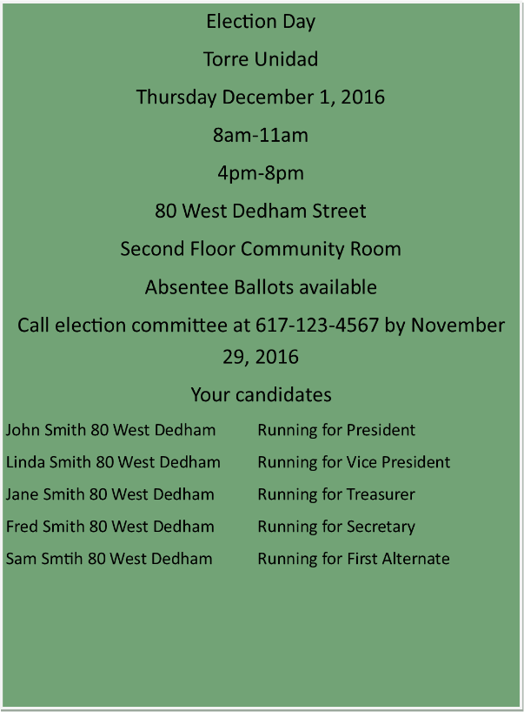

8.8.2 The Election Committee shall conduct a range of activities to encourage resident participation in the election, including holding **candidates' nights and posting notices** to remind residents at least one week before the election.

8.8.3 Candidates for the LTO Board may post and advertise their candidacy in the Development Management office, the LTO office, and other usual posting locations.

8.8.4 Polling stations shall be located in an area of adequate size to provide voters a sufficient level of privacy to mark ballots. The Election Committee shall provide a secured ballot box at each voting station, and shall verify each voter's eligibility as an LTO Member. Upon request by the Election Committee, the Development Manager shall supply a list of legal tenants and their addresses for this purpose.

* The election committee should create a standard voting ballot and absentee ballot with the candidates name and clear instructions on how to vote.
* There shall be no write-in votes allowed on the ballot due to the pre-screening requirement of being lease compliant.

8.8.5 No candidate for election shall be allowed in the voting station other than to cast his/her own ballot. No candidate or his/her supporters shall conduct any campaign activities within twenty (20) feet of the polling station.

* Because all votes are confidential, all ballots will be removed from the premise by the Election Committee and/or poll monitors following the election.

8.8.6 The Election Committee shall provide notice to LTO Members of election results within three (3) calendar days. Notice shall be deemed sufficient by visibly posting the results, including the number of votes cast for each candidate, at both the LTO and Development Management offices.

**Sample:**

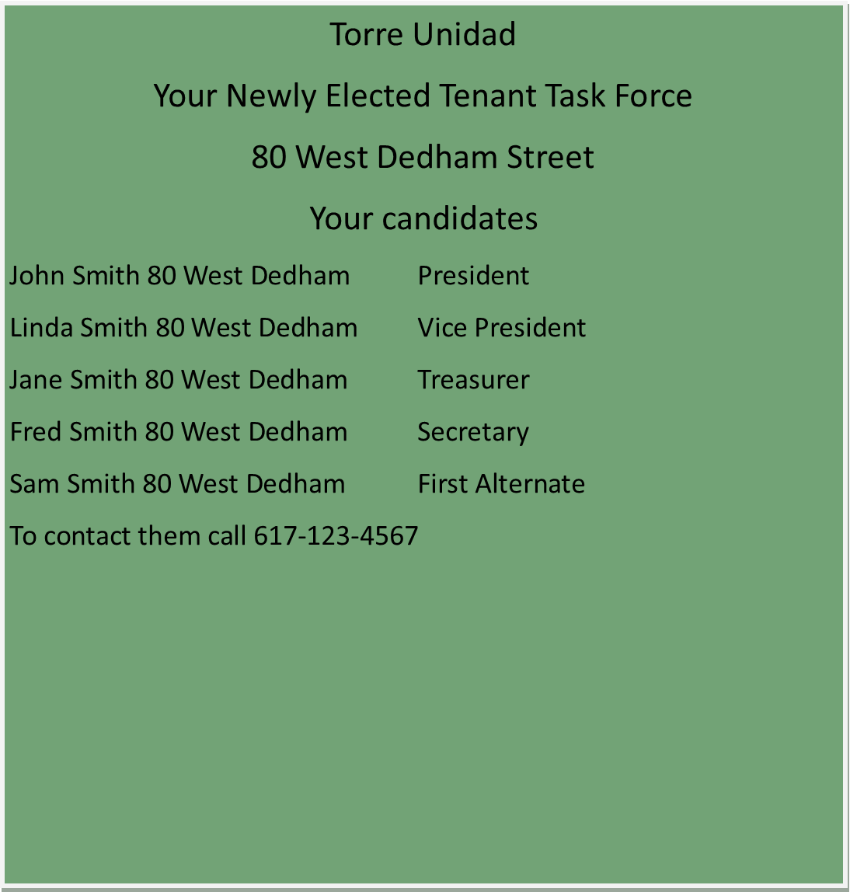

8.8.7 The LTO Board shall provide written notice to the BHA of the election results, including the number of votes cast for each candidate, within ten (10) working days. **(See above picture)**

8.8.8 After an election, the independent third parties shall provide the BHA with a certificate attesting to the fairness of the election. The independent third parties shall provide such a certificate within ten (10) working days on such form and attachments as the BHA directs. **(See sample on pages 48 and 49)**

8.8.9 The LTO Board shall meet within five (5) working days of the election in order to select its officers in accordance with the LTO bylaws.

**_________________________ Local Tenant Organization Elections Ballot**

**Balota de __________________ Asociación de Inquilinos**

**Directions:**

Place an x on the line corresponding with the member you would like to vote for. You may vote for up to five. Once you are done voting fold up this ballot and place it in the box.

**Instrucciones:**

Pon un x en la línea que corresponde con el miembro que usted desea de votar por. Solamente puede votar por cinco o menos candidatos. Cuando termine de votar doble su balota y póngala en la caja.

 Marie Smith ________________

James Smith ________________

 Robert Smith ________________

Mary Jones Smith ________________

Donna Smith ________________

**­­­­­­­­­­­­­­­­­­**

**_________________________ Local Tenant Organization Elections Absentee Ballot**

**Balota de Aucencia de __________________ Asociación de Inquilinos**

**Directions:**

Place an x on the line corresponding with the member you would like to vote for. You may vote for up to five. Once you are done voting fold up this ballot and place it in the enveloped provided to you and seal it up and give it to the poll monitor and/or election committee member. They will deliver it to the box for you.

**Instrucciones:**

Coloque una x en la línea correspondiente al miembro para el que desea votar. Usted puede votar por un máximo de cinco. Una vez que haya terminado de votar, doble esta papeleta y colóquela en el sobre que se le proporcionó y séllela y dársela al monitor de la comité y / o al miembro del comité electoral. Lo entregarán en la caja para usted.

 Marie Smith ________________

James Smith ________________

 Robert Smith ________________

Mary Jones Smith ________________

Donna Smith ________________

**Sample**

**Letter of independent Third Party**

Date: XX/XX/XXXX

Kenzie Bok

Administrator

Boston Housing Authority

52 Chauncy Street

Boston, MA 02111

Dear Ms. Bok,

The Fannie Mae Adult Education Center is writing to verify that we assisted in running the polls on XX/XX/XXXX for the Saint Francis Tenant Task Force Elections in accordance with the BHA Tenant Participation Policy and the 964 Federal Regulations (if state 760 CMR Regulations). Our responsibilities included, meeting with the Saint Francis Election Committee to review the ballots and roles and responsibilities, acquiring a tenant listing to check off voters and verify the are on the lease before handing them a ballot, reviewing the rules of voting, assuring that candidates maintain a 20 feet distance from the voting area, dropping off and picking up absentee ballots.

On Election Day we had two bilingual staff (Spanish and Chinese Speaking) We opened up the polls at 8am until 2pm and then re-opened from 4pm-7pm. We secured all ballots in two lock boxes at the management office until we re-open. No ballots were removed from the lock boxes. With the assistance of the Election Committee counted the ballots starting at 7:15pm until 8pm. All tenants, including the candidates were allowed to watch us open the lock boxes and carry on the count. We gave the ballots to the Election Committee along with our tally sheets and assisted them in posting the results within the required three business days.

Should you have any further questions please feel free to call me at 617-XXX-XXXX.

Sincerely Yours,

Linda Harris

Center for Advocacy

CC:

Resident Capacity Program Staff

**Sample**

**Letter of Election Committee**

Letter must specify what activities were conducted and how they contributed to running a fair democratic election process, how it contributed to outreaching to the extent of the most possible diversity to be on the board and assuring that every eligible tenant had the opportunity to understand the process and make a decision to participate or not.

Date: **XX/XX/XXXX**

Kenzie Bok

Administrator

Boston Housing Authority

52 Chauncy Street

Boston, MA 02111

Dear Ms. Bok,

The Saint Francis Election Committee conducted the election process for the Saint Francis Tenant Task Force in accordance with the BHA policy” Tenant Participation Policy” and the 964 CFR Federal Tenant Participation Policy (or if state 760CMR State Tenant Participation Policy). Our responsibilities included outreach and recruitment, setting up educational meetings, door to door distribution of educational materials, nomination forms and invitations to meetings. We also conducted one on one education as well as door education.

Our election process off with a community meeting after distributing a flyer door to door The meeting was held on **XX/XX/XXXX** were we provided information of the election process and recruited more members onto the Election Committee. Twenty-seven people attended the meeting (see sign in sheets). We created and distributed a multilingual nomination form which included instructions on how to fill it out, who qualifies, and deadlines. To assure a democratic process we distributed the nomination forms to each qualifying member of the household which was 129 potential candidates. We conducted outreach and recruitment for approximately four weeks up until the deadline.

Once the management verified the **seven** candidates’ nomination forms, we met with the candidates on **XX/XX/XXXX** to go over the next steps which included assisting them with crating campaign materials and organizing a Candidates Event. Candidates Social Night was held on **XX/XX/XXXX** it was well attended by sixty tenants (see sign in sheets). Election Day was held on **XX/XX/XXXX.** We send out reminder notices one week prior to the election (door to door) and gave instructions for anyone who needed an absentee ballot to call us. Out of one hundred and twenty six eligible voters, one hundred and twenty voted. We had over 98% coming out to vote. We posted the results of the election three business days as required under the BHA Tenant Participation Policy.

Attach you will find all of the necessary requirements for recognition of the Saint Francis Tenant Task Force, should you have any questions please feel free to contact us at 617-xxx-XXX.

Sincerely Yours,

Juan Smith, Chair of Election Committee

CC:

Resident Capacity Program Staff

8

**Step EIGHT**

OBTAINING RECOGNITION

# STEP EIGHT: OBTAINING RECOGNITION

After the election process the BHA must receive the report within **10 business** along with all the materials used during the election process. This includes all original ballots, bylaws (if a former LTO existed), copies any flyers used to make announcement and/or recruitment, sheets used to tally votes, and reports. Included in the package should be a **Request for Recognition letter** signed by the presidents and a **Letter Arbitrator Agreement** letter also signed by the president.

Below is the list of what will be needed:



|  |  |  |  |
| --- | --- | --- | --- |
| Expectations | Communities expect certain actions to be taken by the newly elected such as advocacy, promoting tenants’ rights, and setting up programs. List other expectations or roles they should play | | |
| Role | How | Role | How |
|  |  |  |  |
|  |  |  |  |
|  |  |  |  |
|  |  |  |  |
|  |  |  |  |

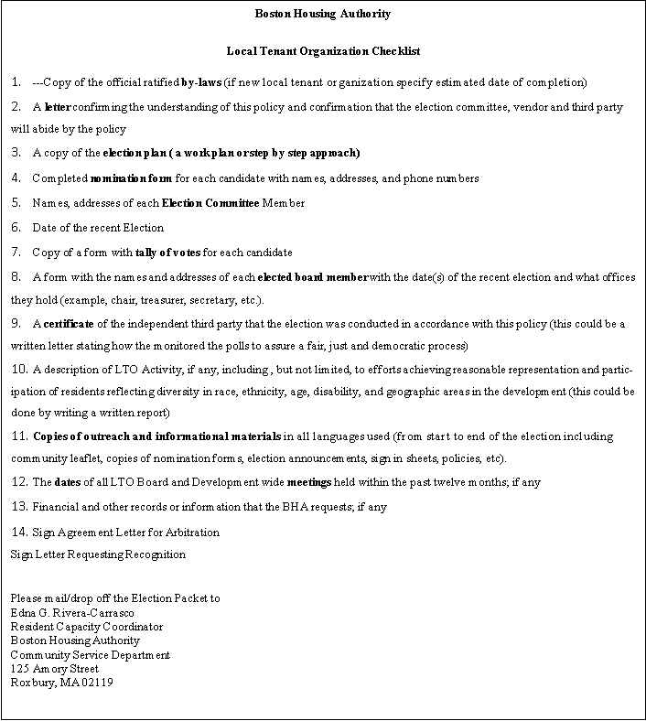

**Sample Letter**

**Agreement for Arbitration**

Date Here XX/XX/20XX

Kenzie Bok

Administrator/CEO

52 Chauncy Street 11th Floor

Boston, MA 02111

Dear Ms. Bok,

This letter is to certify that the St. Francis Tenant Task Force (official name only), will abide by the decisions of an Independent Arbitrator when in dispute with the Boston Housing Authority as defined by the policy “Boston Housing Tenant Participation Policy”.

If you have any questions please feel free to call me a 617-123-4567

Sincerely Yours Sincerely Yours

President Vice President

CC:

Resident Capacity Program Staff

**Sample Letter**

**Requesting Recognition**

Date Here XX/XX/20XX

Kenzie Bok

Administrator/CEO

52 Chauncy Street 11th Floor

Boston, MA 02111

Dear Ms. Bok,

This letter is to request official recognition for the St. Francis Tenant Task Force (official name only), from the Boston Housing Authority as defined by the policy “Boston Housing Tenant Participation Policy”.

If you have any questions please feel free to call me a 617-123-4567

Sincerely Yours Sincerely Yours

President Vice President

CC:

Resident Capacity Program staff

# Other Important submissions



**Election Committee Members**

**Names, Addresses Phone Numbers**

Juan Rodríguez

Tenant

70 St Francis Street Apt 3

Boston, MA 02125

617-123-4567

Lisa Smith

Tenant

70 St. Francis Street Apt 18

Boston, MA 02125

617-891-9101

Shelly Smith

Tenant

70 Saint Francis Apt 56

Boston, MA 02125

781-123-3457

Linda Harris

Beth Israel Deaconess Counseling Agency (interested party)

333 Brookline Avenue

Boston, MA 02125

617-781-0035

**MCj00980470000[1]**

South Street Tenant Association Elections 2013

**Note: You should have no less than three members on your Election Committee as required under the BHA Tenant Participation Policy. For a Copy of the policy visit our website at** [**www.bostonhousing.org**](http://www.bostonhousing.org) **. Click on resident resources**

**Tally vote Sample**

**Election for the (name of development) took place on**

**Election Date: XX/XX/XXXX**

**Number of Voters: 120**

**­­­­­­­­­­­­­­­­­**

**Sample Tally for each Candidate**

John Smith 59 out of 120 voters

Susan Smith 100 out of 120 voters

Deborah Smith 98 out of 120 voters

Perfecta Smith 119 out of 120 voters

Guillermo Smith 106 out of 120 voters

If tenants vote for their officers beforehand then it should look like this

Alternate John Smith 59 out of 120 voters

Treasurer Susan Smith 100 out of 120 voters

Secretary Deborah Smith 98 out of 120 voters

President Perfecta Smith 119 out of 120 voters

Vice President Guillermo Smith 106 out of 120 voters

Please attach the sheet used to tally the votes and sign off with you initials

Sample Tally Sheet you may use a copy of the election ballot to tally

John Smith XXXXXXXX =8 Guillermo Smith XXXXXXX= 9



Susan Smith XXXXXXXXXX= 10 Perfecta Smith XXXXXXXXXXX=11



Guillermo Smith _XXXXXXXXXXX= 11



Person Tallying initial here : JDC

**Sample of Elected Board Members Name and Contact Information**

Saint Francis Tenant Task Force

70 Saint Francis Apt 68

Boston, MA 02125

Office Number 617-988-1234

Fax 617-988-5678

**Last Election was held** on XX/XX/XXXX

Alternate John Smith 70 Saint Francis Apt 1 617-XXX-XXXX

Treasurer Susan Smith 70 Saint Francis Apt 15 617-XXX-XXXX

Secretary Deborah Smith 70 Saint Francis Apt 23 617-XXX-XXXX

President Perfecta Smith 70 Saint Francis Apt 32 617-XXX-XXXX

Vice President Guillermo Smith 70 Saint Francis Apt 53 617-XXX-XXXX

**Expected Meeting Dates for Board**

We recommend that the newly elected members choose a standard meeting day, time and location to avoid conflict in scheduling or confusion. Most bylaws include meeting days chosen by the general membership when the bylaws were ratified, so please review the bylaws.

**First Monday of Every Month**

**6-8pm**

**At Task Force Office located at 70 Saint Francis Apt 68**

**Boston, MA 02125**

September 2, 20XX

October 7, 20XX

November 4, 20XX

December 2, 20XX

January 6, 20XX

February 3, 20XX

Special Meetings as needed will provide no less than three day notice.

**9**

**STEP NINE**

BYLAWS

**STEP NINE: BYLAWS**

The state and federal regulations require that once a local tenant organization is form, they must develop bylaws. It is mandatory that bylaws are created and updated with specific language on the qualifications, rights, and liabilities of membership, and the powers, duties, and grounds for the dissolution of an organization.

**What are bylaws?** Bylaws are the rules and regulations created and followed by an association or a corporation to provide a basis for its operation and management. How are we going to conduct business, behave towards others and what happens if we break the rules.

*(B-laws are a set rules or laws established by an organization or community to regulate itself, as allowed or provided for by some higher authority similar to a parent handbook. It explains what is expected, what is allowed and not allowed.)

The Tenant Participation states the following in creation bylaws

**6. Formation and Bylaws of LTO**

6.1 If a Development has no recognized LTO, and the tenants in the Development wish to establish an LTO, they shall prepare a petition to the BHA signed by the number of potential eligible LTO Members of the Development required by the LTO’s Bylaws, if any, or if there is no such By-law provision, then the recommended number of the lower of 25 or 10% (but in no event fewer than 10) of the potential eligible LTO Members of the Development. Upon receipt of the petition, the BHA shall provide guidance and assistance in the establishment and recognition of an LTO. The potential LTO Members may also seek guidance and advice from other qualified agencies.

6.2 The LTO shall organize and operate as a separate association or entity. Nothing shall preclude the LTO from exercising its rights as an independent organization.

6.3 The LTO shall open and maintain its own fiscal records and its own bank account at a FDIC or comparable state-insured financial institution. The LTO shall not use the BHA’s tax identification and exemption number or other corporate or tax identifying names, numbers, or characteristics.

6.4 The BHA may monitor an LTO’s finances involving any BHA funds at any time.

6.5 The LTO may form partnerships with outside organizations, provided that such relationships are complementary to the LTO in its duty to represent the tenants, and provided that such outside organizations do not become the governing entity of the LTO.

6.6 The LTO shall adopt Bylaws in accordance with this Policy, which shall include the following provisions:

6.6.1 An LTO Member shall be any member of a public housing household who is a designated head of household of any age, or a member of a public housing household at least 18 years of age or older whose name is on the lease of a unit in the Development(s) that the LTO represents, and who meets the requirements of the Bylaws. The LTO may establish additional criteria that are non-discriminatory and do not infringe on rights of tenants in the Development. There shall be no membership fee.

6.6.2 The LTO shall hold Development-wide meetings at least twice per year with the tenants of the entire Development to ensure that tenants have input and are aware and actively involved in Development decisions and activities. Meetings shall be held with reasonable advance notice at times and places that are reasonably convenient and wheelchair accessible, if available at the Development. The LTO shall provide interpretative services as needed, if funds are available. Meetings shall be open only to LTO Members, and LTO Members shall have reasonable opportunity to participate and make their views known. An LTO Member may invite BHA staff members and other non-LTO Members to attend.

6.6.3 The Bylaws may be approved or amended only by a majority vote of the LTO Members present at a Development-wide meeting at which there is a quorum and for which there was reasonable advance written notice, including prominent posting at the Development of the time, date, and purpose of the meeting.

6.6.4 The LTO shall make the Bylaws available to tenants upon request.

6.6.5 The Bylaws shall define the number of LTO Board members required for a quorum of the LTO Board and the number of LTO Members required for a quorum of the LTO.

6.6.6 The Bylaws shall contain procedures for the formation of the LTO Board, the removal of an LTO Board member, and the filling of a vacancy on the LTO Board in accordance with this Policy.

6.6.7 The Bylaws shall contain procedures for regular and recall elections in accordance with this Policy (Article 8). Such procedures described in the Bylaws may include the number of signatures of LTO Members required for nominations.

6.6.8 The Bylaws shall comply with all other applicable laws and policies.

6.7 The LTO shall adopt a dispute resolution process for internal LTO disputes. This resolution process may involve the BHA and its Office of Civil Rights or other qualified agency as a resource to assist in the dispute resolution. (See sample bylaws on pages 67-76)

Requesting an Extension



What should I do if I cannot comply with conducting our development’s elections or meet timelines?

There are several reasons that may arise in which a local tenant organization and/or the election committee cannot meet their deadline to start or complete the election process. If an LTO is unable to comply with their bylaws they shall request from the administrator permission to get an extension. Please note these **qualifying circumstances** should be “beyond the control of the board” qualifying circumstances can include:

1. The development is undergoing re-development negotiations and the current leadership needs to stay in power longer to see the negotiations through because they have the current knowledge.
2. The LTO is unable to get enough individuals to serve on the election committee and need more time to recruit Election Committee Members.
3. The development needs to develop bylaws to guide in the elections process (please note this does not include developments who already have existing bylaws. You are not able to change guidelines before an election process).
4. Election Committee/third party vendor has not met their obligations and followed the required steps to conduct the election process.
5. The general membership and/or board needs training to fully understand the purpose and policies on how to conduct an election process.

The existing board should immediately write a letter to the administrator prior to the deadline of the election date. See sample letter on page 63-66. Note: Each case will be reviewed on an individual basis and approval will be granted with terms and deadlines.

Date: December 9, 2014

Kenzie Bok

BHA Administrator

Boston Housing Authority

52 Chauncy Street 11th Floor

Boston, MA 02111

Dear Ms. Bok,

I am writing this letter in regards to requesting a _______________ **(# of months needed) /or (year)** extension for the _______________ Tenant Task Force elections**. (State reason why you are asking for an extension such as).** We recently completed our bylaws which was a long community process which required the board members individual attention. Since we were elected onto the _______ it has taken us awhile to acquire a full understanding of what it means to be a board member and what type of relationships are needed between the________, our community and BHA management. After two years we are finally beginning to see some progress. With the assistance of BHA management and the CCECR staff we have finally opened up our offices to be able to meet with tenants and meet their needs. We have also began to develop relationships with the partners who are servicing the tenants in our development with full comprehension of what they are and are not providing.

Amongst all this, we feel that our work has not begun. Our goal within the next year is to begin bridging the gap of communication between our diverse populations here at __________________ by promoting programs that increase the social interaction, policy understanding and community engagement, but more importantly increase trust. Our current bylaws require us to start the election process now in December in order to affectively educate, recruit and conduct an election process. This election process will consume our time leaving no room for us board members to concentrate on the real needs of the _____________ health tenants. In addition, we feel it will be contrary to our mission to bring in new members without having the proper resources and support in place for them. An extension will allow us to not only begin the process of the election, but also allow us to work on other important matters while alleviating the pressure of meeting the required timeline. We are proposing the following schedule

|  |  |  |
| --- | --- | --- |
|  | Goal | Activity |
| Jan 15 | Begin identifying tenants to fill in vacancies | Post notice under each household using a multi-lingual recruitment flyer |
| Feb 15 | Identify tenants and partners to be part of the Election Committee | Create Newsletter requesting volunteers onto the election committee |
| Mar 15 | Promote a social event to emphasize importance of community engagement through trust | TBD |
| Apr 15 | Identify Third Party Vendor to conduct elections  Train Election Committee | Board members identify and vote on third party at their Board meeting  BHA-CCECR staff will train Election Committee |
| May 15 | Develop Election Work Plan with third party. Work plan must clearly state how it will reach a diverse population | Establish small committee made up of board members, third party and tenants from the community (could be on the election committee or just volunteers) |
| June 15 | Begin recruitment process | Development and Distribution of nomination forms with requirements |
| July 15 | Unity Day | Date and time to TBD |
| Aug 15 | Candidates Event | Date and time to TBD |
| Sept 15 | Election Process | Date and time to TBD |
| Oct 15 | Transition Period for new and current | Set-up series of meetings. Current members will assist new members navigate the BHA and community systems |
| Nov 15 | Training for new and current board members | Trainers TBD |
| Dec 15 | Transition finalize |  |

We hope you consider our request for a one year extension. We thank you and your staff for all of the support they have and continue to give us and we look forward in hearing from you.

Sincerely Yours,

Signature here

________________ Tenant Task Force President

BYLAW TEMPLATE



BY LAWS FOR _______________________________ (Name of the local tenant organization)

**ARTICLE I: Name, Principal Location, Purpose, and Fiscal Year.**

Section 1 Name: The name of the local tenant organization (LTO) is: _____________________________________________________________

Section 2 Principal Location: The principal location of the LTO shall be _____________________________ within the Boston Housing Authority’s ________________________ public housing development. The Board of Directors may change the principal location, which will be effective upon a certificate of the change being filed with the Secretary of State for the Commonwealth

Section 3 Purpose: The purpose of the LTO is to empower public housing residents at the Boston Housing Authority’s ____________________ public housing development to fully participate in decisions affecting them involving the Boston Housing Authority (BHA) or other agencies, to educate residents regarding their rights and responsibilities, and to enhance economic opportunities and self-sufficiency for all residents.

Section 4 Fiscal Year: The fiscal year of the corporation shall begin on ______and end on ___________ of each year.

**ARTICLE II: Membership, Board of Directors, Officers**

Section 1 General Membership

1. Definition of General Membership: The General Membership of the LTO shall consist of the residents of the __________________public housing developments of the BHA who have voting rights.

1.2_ Voting Rights of General Membership: The General Membership shall have rights to elect or recall the members of the Board of Directors (as described in Article III below), to adopt and revise Bylaws, and to take such other steps as may be necessary to achieve the purpose of the corporation. The General Membership shall have the right to participate in the LTO and its committees. Voting rights will be vested in all residents of the ______________________________ development who are 18 years of age or older, or who are emancipated minors who are leaseholders in such development, as listed on BHA leases or Tenant Status Review (TSR) reports. Residents who have vacated the development will no longer have voting rights, except in instances where the development are undergoing redevelopment and members of the corporation must temporarily relocate off site, but have rights to permanently relocate back to the development. Voting rights can only be exercised by persons present at a General Membership meeting; there shall be no voting by proxy. Each member shall only have one vote.

1.3_Meetings: There shall be at least _____General Membership meetings a year. One of these meetings shall be the annual meeting, held in _________ of each year. At this annual meeting, members will receive annual reports, financial reports, and other information as specified by at least ________ members of the Board of Directors. The purpose of these meetings will be to inform residents on matters of general interest, including the solicitation of input regarding BHA maintenance, modernization efforts, and revisions in BHA policies. Additional meetings of the General Membership may be called by the Chairperson of the Board of Directors (or, in the Chairperson’s absence, the Co-Chairperson), by ________members of the Board of Directors, or on a written request of ____ percent (___%) or more of the General Membership. Written notice concerning such meetings and the proposed agenda items for such meetings shall be provided to all resident households at least seven (7) days in advance of the General Membership meetings. Items for the agenda of the General Membership meeting may be added by advance written request of ______ or more members of the General Membership. An annual report shall be prepared and presented by the Board of Directors. There must be a quorum of at least __________ (__) members before any action can be taken at a General Membership meeting.

Section 2 Board of Directors

2.1 Number of Members: The Board of Directors of the corporation shall consist of fifteen (__) members

2.2 Requirement of Membership in Corporation: All Directors shall be active members of the corporation. If a Director no longer has voting rights as a member of the corporation due to vacating the development (see Section 1.2 above), he or she shall resign or be removed from the Board of Directors.

2.3 Election and Term: Each member of the Board of Directors shall be elected by the General Membership at the Election meeting of the LTO, as described in Article III below, and shall hold office for a ____ year term, unless the Director resigns, is removed for good cause by the Board of Directors, or is recalled by the General Membership. The Board of Directors shall serve for a short period after the election of its successors (but in no case more than one month after the election) in order to wrap up and transition business to the new Board of Directors.

2.4 Attendance of Meetings and Participation in Committees: Members of the Board of Directors are required to attend meetings of the Board and the LTO and to actively participate on at least one committee.

2.5 Quorum: Quorum for meetings of the Board of Directors is _____ (__) members. However, if the Board is voting on whether to remove a Director or Officer for good cause, to fill a vacancy on the Board of Directors, or to recommend amendments to the Bylaws, the quorum for such a meeting shall be ______ (__) members.

2.6 Filling of Vacancies: If a vacancy occurs in the Board of Directors prior to the next scheduled election, such vacancy shall be filled by the Board of Directors. The Board of Directors shall give written notice of such vacancy to the General Membership and give the General Membership a reasonable period of time (but not to exceed four (4) weeks) to submit names for consideration for appointment to the Board. The Director so appointed shall hold office only until the next election. Reasonably prompt written notice shall be given to the General Membership and to the BHA of any vacancy caused by resignation or removal of a Director and the name and address of the person appointed by the Board of Directors to fill the vacancy.

2.7 Resignation: A Director may resign from the position by delivering a letter of resignation to the Chairperson (or, if the person resigning is the Chairperson, the Co-Chairperson). Such resignation shall be effective upon receipt and acceptance of the letter by the Board of Directors.

2.8 Removal for Good Cause: Any member of the Board of Directors may be removed from office for good cause at any time by the Board of Directors at any meeting by a majority vote of the Board members present at such meeting. The following shall constitute good cause: (1) Absence from three board meetings without excuse; (2) Violating the confidentiality of residents; (3) Accepting a paid position with the BHA or a contracted management company at the Charlestown development, or a paid position with the BHA in a policy-making or supervisory position elsewhere, provided however, a Director’s participation in a BHA advisory capacity, such as on the Monitoring Committee or the BHA Resident Advisory Board, shall not require the Director to resign or be removed from office; (4) Misusing the organization’s office or name; (5) Failure to resign after losing membership in the corporation, as described in Sections 1.2 and 2.2 above; or (6) Any breach of the Director’s duty of loyalty to the corporation or its members; (7) For acts or omissions not in good faith or which involve intentional misconduct or a knowing violation of law, or (8) For any transaction from which the Director derived an improper personal benefit. Any action on removal must be preceded by written notice to all members of the Board of Directors, at least two (___) weeks in advance of the meeting, stating that the issue of removal shall be considered at that meeting, and stating the grounds for removal.

2.9 Meetings of the Board of Directors: The Board of Directors shall meet at least ____ a month at a regular time and place which shall be posted and made generally known to the General Membership. Special meetings may be called by the Chairperson (or in the Chairperson’s absence, the Co-Chairperson), or by written request of ____ (__) Directors to the Secretary. Notice of any special meeting shall be given at least _____ (__) days in advance to all Board members, and shall also be posted. Generally, Board of Directors meetings shall be open to the General Membership, but the General Membership shall not have voting rights at such Board of Directors meetings. The Board of Directors can, however, call an executive session and close the meeting (or a portion of such meeting) to all but the members of the Board of Directors by a vote of ____ (__) Directors. Written agendas for the Board of Directors meeting shall be prepared and provided in advance to all Directors, and shall be posted at the meeting place where the Board shall meet, and shall be made available to the General Membership upon request. Each member of the Board of Directors shall have one vote, and a member must be present at the meeting in order to determine quorum and to vote; there shall be no voting by proxy or phone.

2.10 Duties: The Board of Directors shall develop and carry out the policies and programs of the LTO. They shall establish the committees for the LTO and coordinate their work. They shall report regularly to the members of the organization. They shall represent the interests of the General Membership before the BHA and other groups and agencies. The Board of Directors shall administer any funds received by the LTO responsibly and for the benefit of the General Membership, consistent with the LTO’s purpose.

2.11 Powers: The Board of Directors shall have the following powers:

(A) Election and removal of Officers;

(B) Filling of vacancies on the Board of Directors;

(C) Removal of Directors for good cause;

(D) Authorization of expenditures;

(E) Employment of persons as necessary to achieve the corporation’s purpose;

(F) Receiving funds for the use of the corporation and the General

Membership;

(G) Establishment of a bank account thru a third party agency

(H) Establishment and revision of committee structure;

(I) Acting on behalf of the General Membership in matters involving the BHA and regulatory agencies.

Section 3 Officers

3.1 Election of Officers and Responsibilities: The following Officers shall be elected by the Board of Directors from among themselves at their first meeting following their election by the General Membership:

(A) Chairperson–The Chairperson shall chair all meetings of the Board of Directors, preside over General Membership meetings, represent the General Membership and the Board of Directors, sign all correspondence on behalf of the corporation (except as the Board of Directors may otherwise designate), and exercise general supervision and control of the affairs of the LTO. The Chairperson shall have the normal power to vote in the Board of Directors and the General Membership and to make or second a motion.

(B) Co-Chairperson–The Co-Chairperson shall perform the duties of the Chairperson when the Chairperson is absent or unable to perform his/her duties.

(C) Secretary–The Secretary shall record and maintain minutes of all Board of Directors and General Membership meetings and shall insure that proper notice of Board meetings and General Membership meetings is given. The Secretary shall also function as the Clerk of the LTO under the terms of any Articles of Organization. In the absence of the Secretary, a temporary secretary may be elected to record the minutes of the meeting concerned.

(D) Treasurer–The Treasurer shall have general charge of all financial affairs of the LTO. The Treasurer shall ensure accurate record keeping with respect to the corporation’s and Board’s financial affairs, and shall sign off on checks requests authorized by the Board of Directors. The Treasurer shall provide regular financial reports to the Board of Directors and to the General Membership on the LTO’s financial affairs. All payments requested of the LTO shall have, in addition to that of the Treasurer, the signatures of at least the Chairperson (or, in the Chairperson’s absence, the Co-Chairperson) or Secretary.

3.2 Term of Office; Resignation, Removal from Office, and Filling of Vacancies: The Officers’ term of office shall be the same as the Board of Directors. An Officer may resign by giving written notice to all other members of the Board of Directors. The Board of Directors may also remove any Officer for good cause by a majority vote. “Good cause” shall be defined in the same manner as in Article II, Section 2.8 of these Bylaws. The Board shall fill any vacancies in Officer Positions from the members of the Board of Directors. The resignation or removal of an Officer shall not be deemed to also be a resignation or removal from the Board of Directors unless this is stated in the resignation, or the Board’s decision. Any Officer who resigns or is removed from Officer shall have the responsibility to turn over any of the Board’s records and accounts to the Board of Directors. Reasonably prompt written notice shall be given to the General Membership and to the BHA of any vacancy caused by resignation or removal of an Officer and the name and address of the person appointed by the Board of Directors to fill the vacancy.

**ARTICLE III: Election of the Board of Directors by the General Membership; Recall**

1.1_ Elections every ___ (_) Years; Eligibility to serve on the Board of Directors: Elections shall be held every ____ years for the Board of Directors. All members of the General Membership shall be eligible to serve as members of the Board of Directors, so long as they are not employed by the BHA in a policy-making or supervisory position and are not employed by the BHA or a contracted management company at the __________ development.

1.2_Election Committee: The Board of Directors shall establish an Election Committee to assist the corporation in conducting its election of the Board of Directors. No person who will be a candidate for the Board of Directors may be a member of this committee. The committee shall consist of residents, and can include third-party volunteers who do not reside at the development. The Election Committee shall implement and oversee all election activities as well as ensure the LTO’s compliance with all relevant election requirements, including those provided by the BHA’s policy, “Participation of Recognized Local Tenant Organizations in the Administration of Boston Housing Authority Local Developments.”

1.3_Notice of Election Procedures: The Election Committee, working in conjunction with the Board of Directors, shall ensure that all voting member households will be given written notice at least seventy-two (72) days in advance of the election of the election procedures. The notice will be delivered to each occupied unit of the development and shall include a description of the election procedures, eligibility requirements, deadline for submission of nominations and for the election, and a copy of nomination papers. To ensure the notice solicits the broadest possible attention of residents and encourages their participation in the electoral process, such notices shall be translated from English into at least the three most appropriate languages for the developments’ population. The BHA shall, upon request of the Chairperson to the manager of the developments, provide copies of these translated materials and assist in their distribution to each household. Such request must be made to the manager forty-five (45) days prior to the initial election notice, to give the BHA sufficient time to prepare such materials. The Election Committee and the Board of Directors shall ensure that these time frames for translation of materials are met where necessary to ensure broad participation. The notice of election procedures shall provide clear instructions where nomination papers may be obtained, who is an eligible candidate, and how the nomination form is to be completed, where and when it is to be filed, and the number of residents whose signature is required in support of the nomination. Nomination papers, in addition to being attached to the initial notice, must also be available to residents at both the LTO’s office and the BHA management office.

1.4 Number of Signatures Required for Nomination: Each candidate for the Board of Directors must obtain at least _________ (___) signatures from the General Membership in order to be eligible as a nominee for the Board of Directors. Members of the General Membership may sign more than one candidate’s nominating papers. Multiple signatures by the same member on a candidate’s nomination papers shall be stricken.

1.5 Period for Nominations; Submission of Signatures to the BHA for Verification; Certified Papers Remaining on File: Nominations must remain open for a minimum of at least six (6) weeks from the date of the initial election notice. BHA shall verify that the signatures that appear on the nomination papers represent names of legal household members eligible to vote in the election; BHA shall not certify if the signatures are authentic. To ensure candidates an opportunity to avoid having their nomination papers rejected for an insufficient number of certifiable names, a preliminary inspection of nomination papers by BHA management shall be conducted fifteen (15) days prior to the end of the nomination period. Those candidates who fail to submit nomination papers on or before this preliminary date do so at risk of being rejected from the election. The certified nomination papers shall be maintained on file with the Election Committee and the Board of Directors until the following election.

1.6 Encouraging Diversity in Candidate Pool: The Board of Directors and the Election Committee shall attempt to achieve reasonable representation on the Board of Directors of all racial and ethnic groups and all geographic areas within the Charlestown development.

1.7 Notice of Nominations; Encouraging Resident Participation: The Election Committee and the Board of Directors shall give written notice to all member households by way of leaflets regarding the certified nominees for the Board of Directors. The notices shall display a sample ballot with each candidate’s name and address listed. Such notices shall be posted in every hallway, management, and corporation office at a minimum of thirty (30) days prior to the election. The Election Committee and the Board of Directors shall conduct a broad range of activities to encourage resident participation in the election through candidates’ nights, providing poster and leaflet materials to candidates for campaign purposes, and/or issuing election reminder notices to residents, consistent with resources available to the LTO.

1.8 Conduct of Election: The Board of Directors and the Election Committee shall obtain an impartial third party to monitor the balloting and tabulation processes. At the time of the election, polling stations will be located in an area of adequate size to provide voters a sufficient level of privacy to mark ballots. A secured ballot box shall be provided at each station, and the Election Committee shall verify each voter’s eligibility (based on lease and TSR information provided by BHA). The persons staffing the polling stations and acting as third party observers shall be impartial. No candidate for election may be allowed in the polling station other than to cast his/her own ballot. No campaign activities shall be conducted by any candidate or his/her supporters within twenty (20) feet of the polling station.

1.9 Notice of Election Results: Within three (3) days of the election, the Board of Directors and the Election Committee shall provide notice to the General Membership of the election results by posting the same at both the corporation’s office and at the BHA management office. The Board of Directors and the Election Committee shall provide notice to the BHA of the election results within ten (10) working days of the election. The correspondence to BHA shall include a list of all Board members elected, their addresses, and a description of election procedures. It shall also include a request for recognition of the new Board of Directors and a letter from the new members of the Board of Directors, agreeing to abide by arbitration, consistent with the requirements of BHA’s Public Housing Tenant Participation Policy.

1.10 Petition for Recall: The General Membership may move to recall one or more members of the Board of Directors during the Director’s term of office. In order for the General Membership to recall a Director, there must be a written petition containing the signatures of at least twenty percent (20%) of the adult household members of the development. Such recall petition shall have a clearly stated reason for the recall typed at the top of each page of signatures. The reason for recall is not limited to the reasons for removal for good cause stated in Article II, Section 2.8.

1.11 Recall Election; Limitation on Further Petitions for Recall of Same Director: Upon receipt of a recall petition in the proper form and with the proper number of signatures, the Board of Directors shall promptly call a meeting of the General Membership for the purpose of having a recall election. The notice of the meeting shall state the date, time and place of the meeting, the purpose of the meeting, and the grounds stated for recall in the petition. The recall election need not take the form of the general election provided for above. The General Membership shall be free to choose several options for recall, including designation of a particular person to serve as a Director in lieu of the Director proposed for recall, or granting the Board of Directors the discretion to appoint another person as Director for the balance of the term. If the majority of the General Membership present at the meeting votes to recall the Director, the Director shall be recalled. Reasonably prompt written notice shall be given to the General Membership and to the BHA of the outcome of any recall election. If the General Membership decides not to recall a Director, no petition to recall that same Director shall be considered until a 12-month period has lapsed from the submission of the last petition. This shall not, however, be a limitation on the power of the Board of Directors to remove a Director for “good cause” in accordance with Article II, Section 2.8.

**ARTICLE IV: Committees**

1.1_ Standing Committees: The Board of Directors shall establish standing committees to carry out the goals and objectives of the corporation. It shall actively recruit the General Membership to serve on committees to ensure democratic participation and to further the goals of the LTO. The standing committees shall report to the Board of Directors and to the General Membership on their ongoing work.

**ARTICLE V:External Representation**

1.1_The Board of Directors shall appoint representatives of the LTO who will serve on other boards and organizations.

1.2_Any such representative may be removed for good cause at any time by the Board of Directors at any meeting upon the vote of the majority present.

**ARTICLE VI: Personal Liability of Officers and Members of the Board of Directors; Conflict of Interest**

Section 1: Personal Liability

1.1_The Board of Directors shall not have the power to bind the members of the Board personally or call upon such members to discharge any debts. The members of the Board of Directors and the Officers shall not be held personally liable for any debt, liability or obligation of the LTO. This provision, however, shall not eliminate or limit the liability of an Officer or a member of the Board of Directors for any breach of the Officer’s or Director’s duty of loyalty to the LTO or its members, for acts or omissions not in good faith or which involve intentional misconduct or a knowing violation of law, or for any transaction from which the Officer or Director derived an improper personal benefit.

Section 2 Conflict of Interest

2.1 The Conflict of Interest provisions of any state or federal statutes or regulations that apply to public housing or non-profit corporations shall be in force with respect to the LTO, including any decisions to hire personnel or to expend funds. No member of the Board of Directors or members of the immediate families of members of Board of Directors shall be employed by the LTO.

2.2 Gifts, goods, services, and funds provided to the ______________________ development must be equitably distributed, and no member of the Board of Directors, members of Committees, or members of the immediate families of such persons shall benefit from such gifts, goods, services, or funds in a manner disproportionate with the benefits received by the General Membership; provided, however, nothing in this provision shall bar members of the Board of Directors or committee members from being reimbursed for legitimate expenses that they have incurred while acting on behalf of the LTO.

**ARTICLE VII: Amendment of Bylaws**

1.1_ Procedure for Amendment of Bylaws: The Bylaws may be amended by a majority vote of the General Membership at a regular or special General Membership meeting. Any amendments may be proposed by a majority vote of the Board of Directors. The Board of Directors shall ensure that written notice is provided to all resident households at the Charlestown development at least _____ (__) days in advance of such meeting. Such notice shall state the date, time and place of such meeting, that it is proposed that the Bylaws be amended, and a summary of the proposed changes in the Bylaws. Members of the General Membership shall be free to propose other changes to the Bylaws at such meeting, but such proposals must be made in writing and shall be read and explained to all persons present at such meeting in advance of being voted upon.

1.2_Limitation on Certain By-Law Amendments: No By-Law amendment shall be proposed or adopted which would have the effect of disqualifying the LTO from recognition as a Local Tenant Organization (LTO) under the BHA’s Public Housing Tenant Participation Policy, as the same may from time to time be lawfully amended, or applicable lawful HUD or DHCD requirements governing participation of LTOs in the affairs of public housing authorities. No By-Law amendment shall be proposed or adopted which will be contrary to the provisions of G.L. c. 180 as the same apply to non-profit corporations.

Disclaimers:

Although information included in this manual have been produced and processed from sources believed to be reliable, no warranty expressed or implied is made regarding accuracy, adequacy, completeness, legality, reliability or usefulness of any information. This disclaimer applies to both isolated and aggregate uses of the information

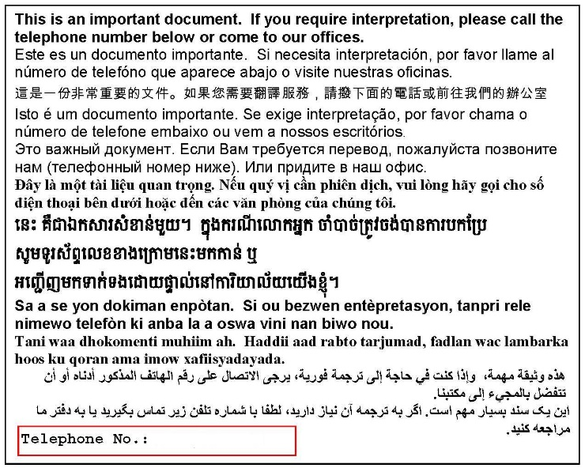

617-988-5292