March 19, 2020

Dear BHA Program Participant,
With evolving news of COVID-19, the Boston Housing Authority is announcing heightened restrictions at its Chauncy Street Headquarters and other locations in order to limit in-person contact and protect BHA residents, voucher holders and staff.
Until further notice, we will provide essential services to you by mail, email, phone and fax and ask for your patience as we limit public visits to our offices.
For the immediate future, annual recertifications will be conducted by mail, fax, and email. If you have interim changes to report, please send them by email, mail, or fax. Also, don’t hesitate to send pictures of documents to your Leasing Officer using your smart phone if you have one. Enclosed with this letter is an Interim Request form should you need to report any changes to your Leasing Officer.
Your Leasing Officer is: Email:
Tel:
Fax:

You can download and print relevant forms here: bostonhousing.org/lhforms
Additionally, we have paused our annual inspections. This just means that your annual inspection may be delayed until later this year if it was scheduled to occur in the near future. You can still contact our inspection department by calling 617-522-0048 for any issues that arise in your apartment, and we will respond accordingly.
Should you need them, there are free food sites set up throughout the city and we are working closely with the City of Boston to ensure that everyone is able to get needed food and medicines. Further information will be distributed and can be found at www.boston.gov. Call 311 to reach the City of Boston’s Health Line if you have questions about the virus, if you live outside of the City of Boston – call 211.
Most importantly, we are encouraging all of our participants to follow basic COVID-19 guidance related to prevention: frequent hand-washing; avoiding touching your face; limiting visitors; cleaning high-touch surfaces frequently; and practicing social distancing. Social distancing means seriously limiting in-person contact with others, and when it is necessary to be in the same room, keeping six feet away from others. You can view updated information at www.bphc.org or at your town’s local board of health.

Thanks,

David Gleich
Chief Officer of Leased Housing Programs

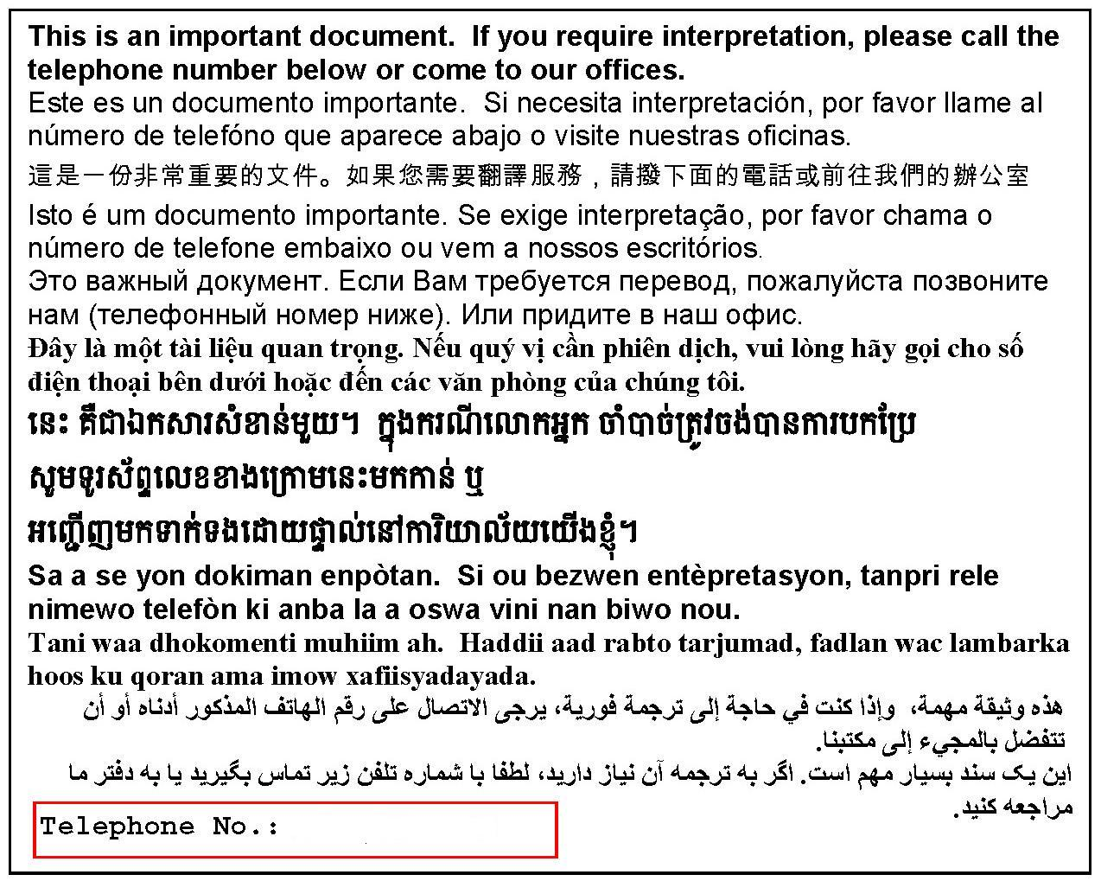
(617) 988 - 4400

