An equal opportunity employer. **A home for every story**

**Information Systems**

52 Chauncy Street, 6th Floor

Boston, Massachusetts 02111

P 617.988.4080 F 617.988.4292

TDD 800.545.1833 x420

www.bostonhousing.org



**Admissions Department**

52 Chauncy Street, 3rd Floor

Boston, Massachusetts 02111

P 617.988.3400 F 617.988.4214

TDD 800.545.1833 x420

www.bostonhousing.org

# Admissions

# New Application Workflow - Portal

4/10/2025

Table of Contents

Admissions 1

New Application Workflow - Portal 1

Background 1

Applying Online – BHA Portal/WebApp 2

About 2

Applying in BHA Portal (First-time users) 2

Applying in BHA Portal (returning users) 9

Navigating the Website/ Updating application in BHA Portal 12

## Background

Admissions utilizes two different web-enabled online application software systems. The two systems are CHAMP and My Housing – Web App (aka Portal). The CHAMP application is used for the collection and processing of MA State assisted housing. The Web App application is used for the collection of Federal Assisted Housing.

The Admissions – New Admission Workflow - Portal document is intended for Applicants. The procedures that follow can be used by the applicants as a guide for applying through BHA Portal/WebApp. The purpose of this document is to outline the required steps to enter an application for BHA Federal Assisted Housing. This document is not meant to outline any qualifications needed by the applicants. Also, this document will explain any idiosyncrasies of the data entry screens provided.

# Applying Online – BHA Portal/WebApp

## About

BHA uses and manages the BHA Portal/ WebApp, which is a tool used for entering applications, updating applications, viewing your statuses and current lists among other things.

### Applying in BHA Portal (First-time users)

1. Go to <https://boston.myhousing.com/?abandon=False>
2. Click on Start Here 

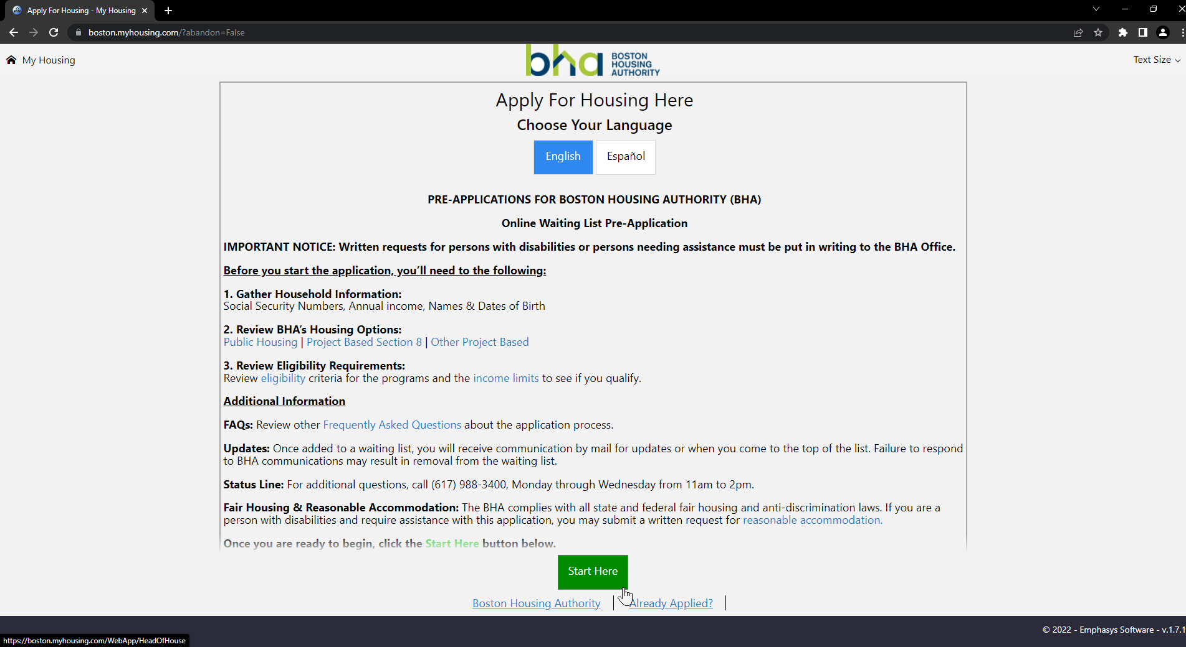

Important Note!

You are responsible for reviewing the eligibility criteria and income limits prior to applying.

1. Enter your (Head of Household’s) information.

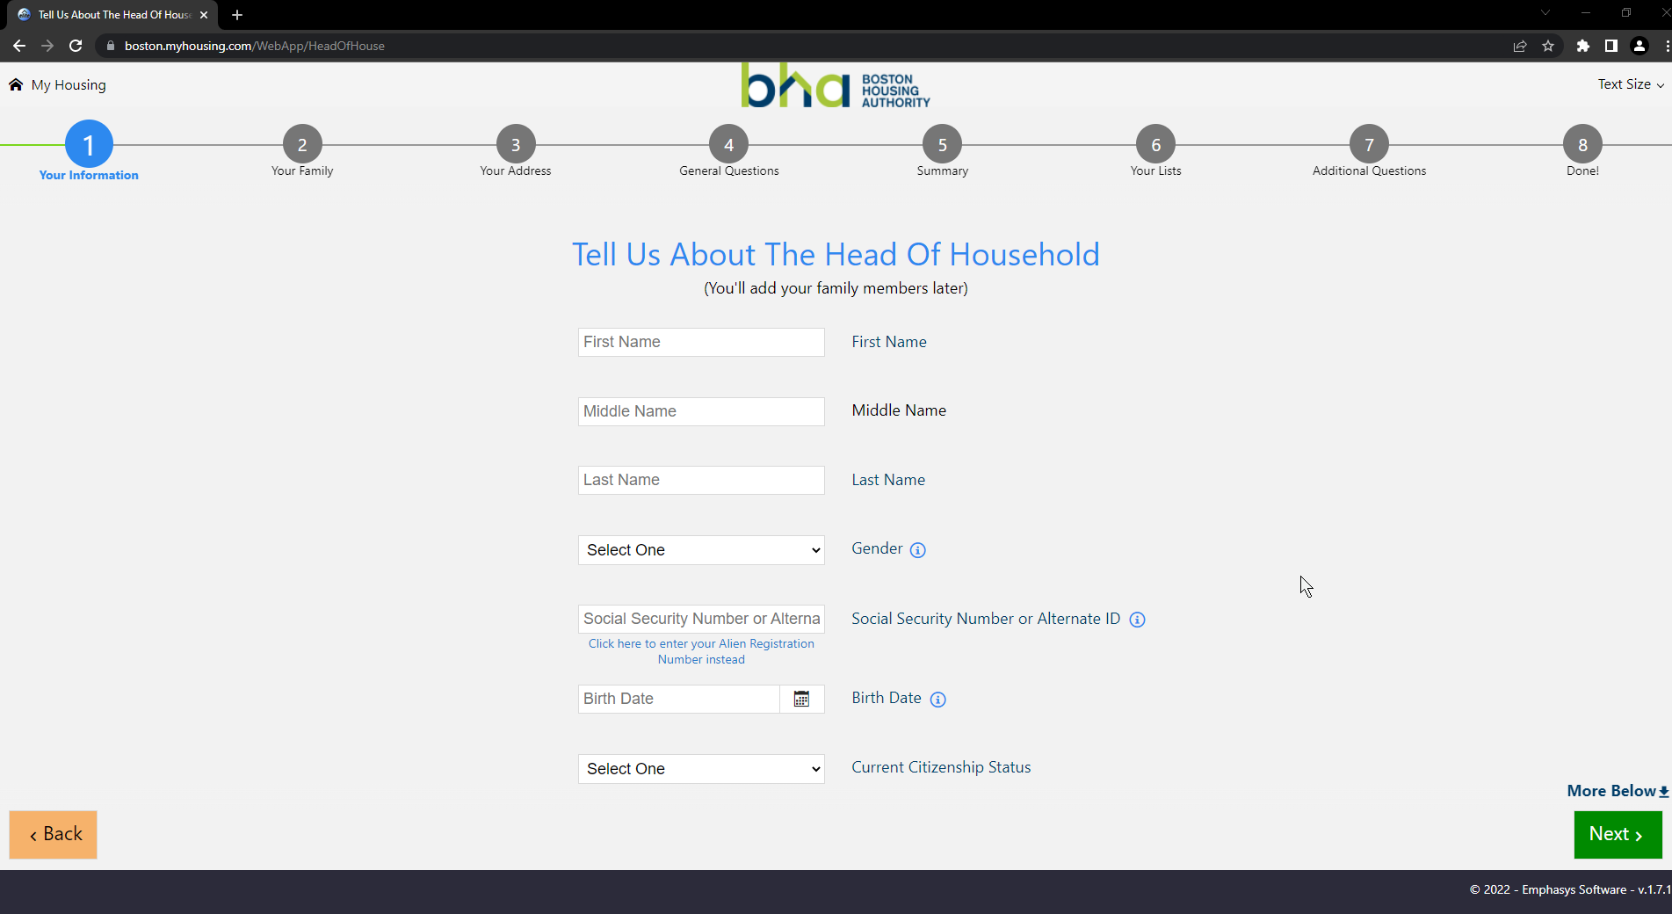

Important Note!

Please be sure the information you’re entering here is accurate to the best of your knowledge. Your name, Date of Birth and Social Security Number are important pieces of personal identifying information which BHA uses to uniquely identify you, any inaccuracies here might lead to you not being able to apply in a timely manner.

1. Click on Next 
2. Select number of additional household members (**NOT** including yourself) you have in your family and want to add to this application
3. Enter the information of your family members

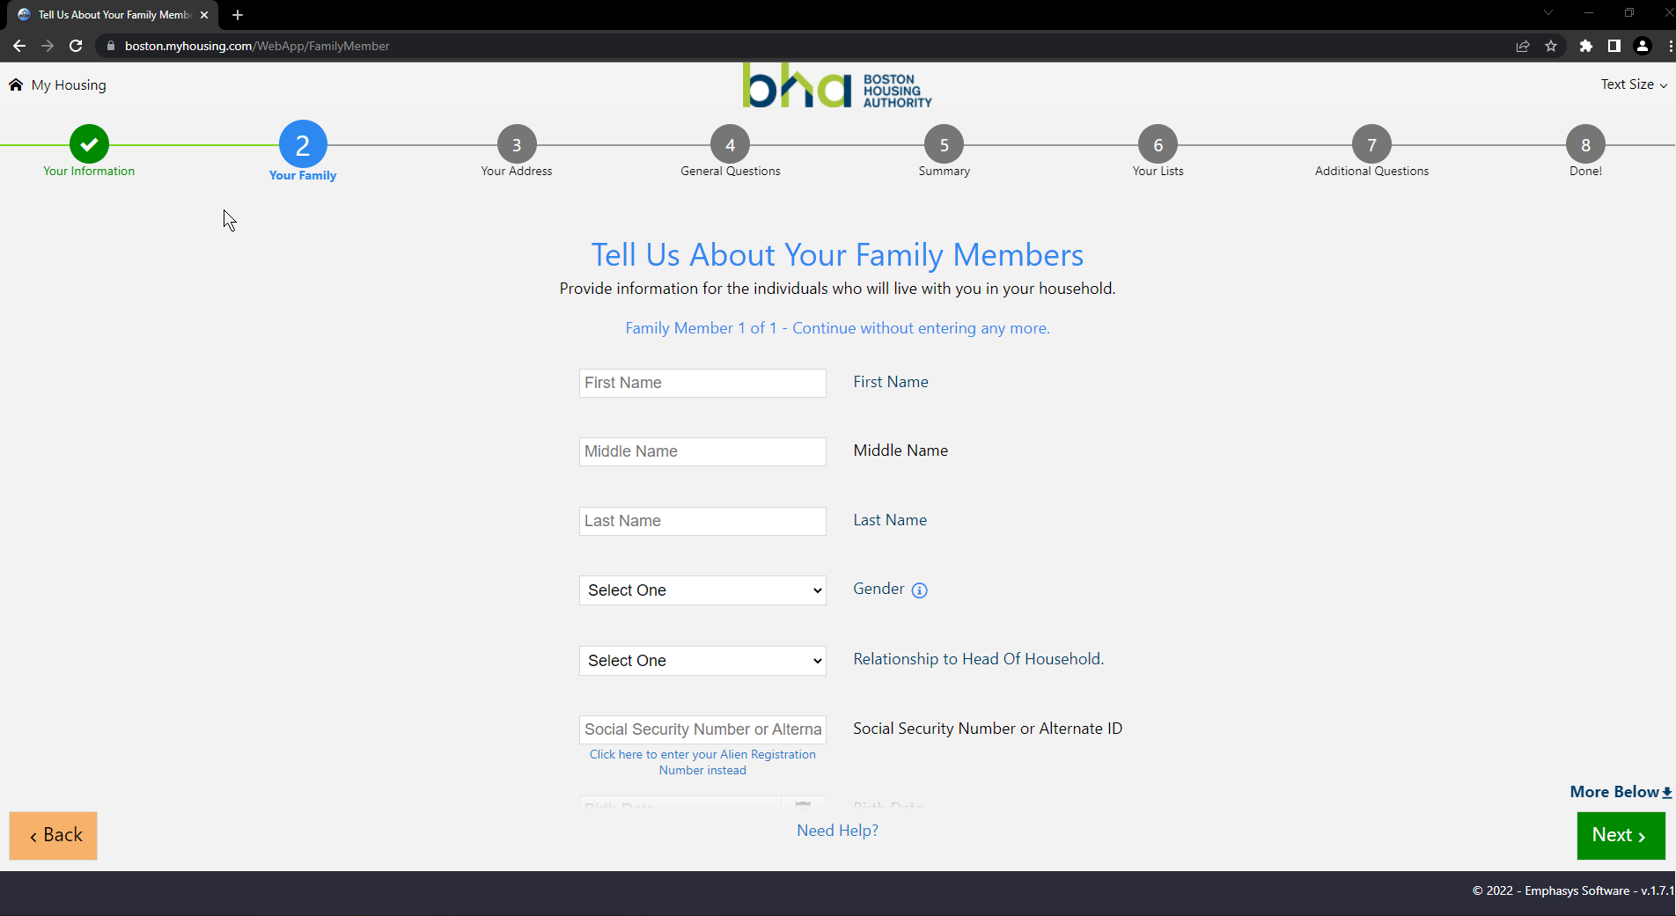

1. Click on Next 
2. Enter your address

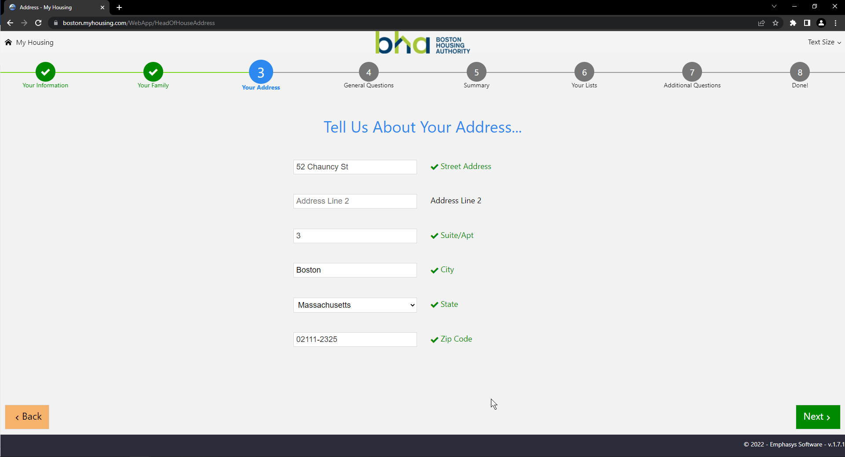



1. Click on Next
2. Click on Use this corrected address 

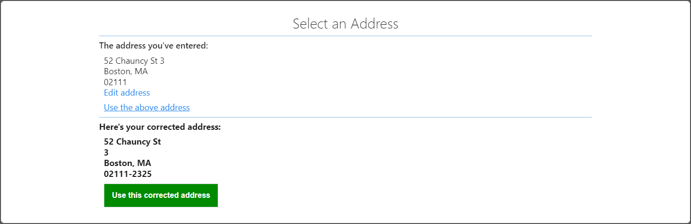

1. Answer the general questions about your eligibility

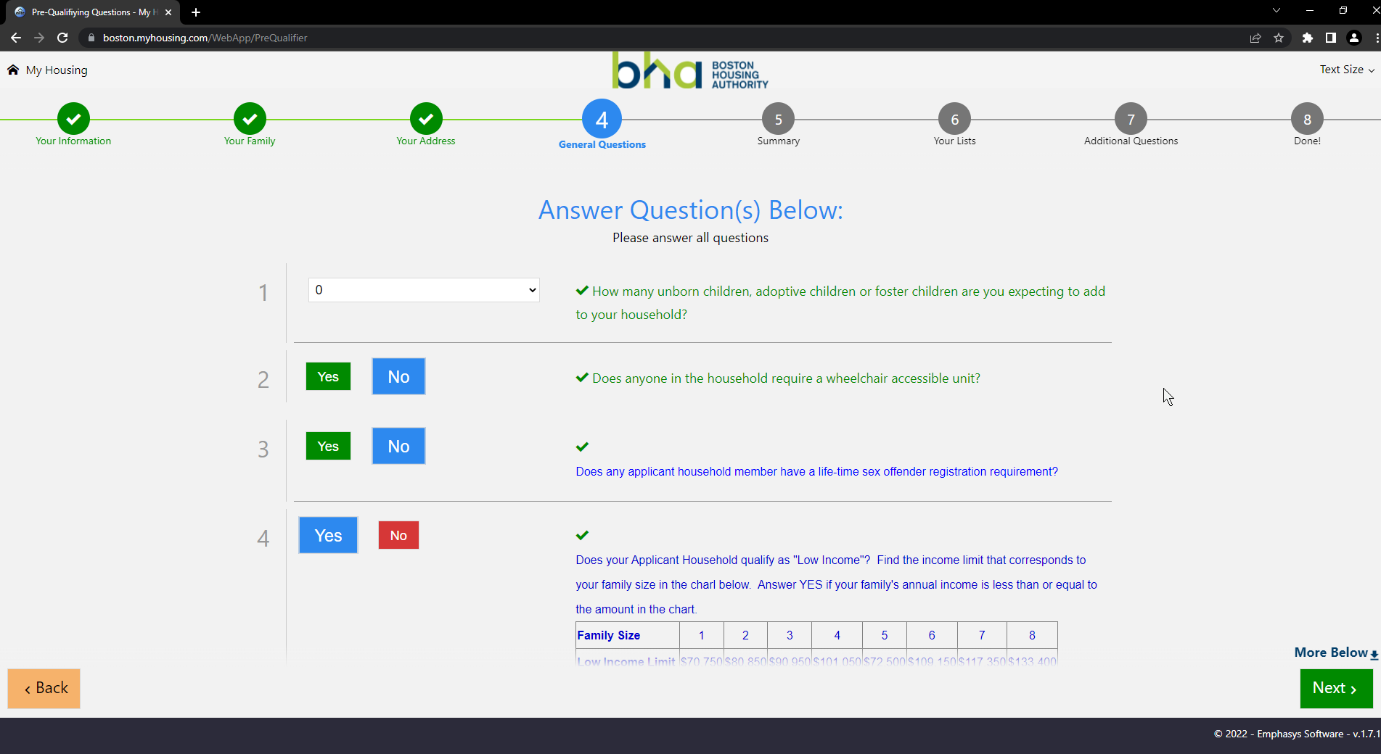

Important Note!

The information about you, your family and your answer to these questions determines your ability to apply on various BHA waiting lists. Please read all the questions carefully.

* If you qualify for “Very Low Income”, please also answer **Yes** for “Low Income” question.
* If you qualify for “Emergency Housing Situations”, please also answer **Yes** for the “Elderly or Emergency Housing Situation” question.



1. Click on Next
2. Verify the information you’ve entered so far.

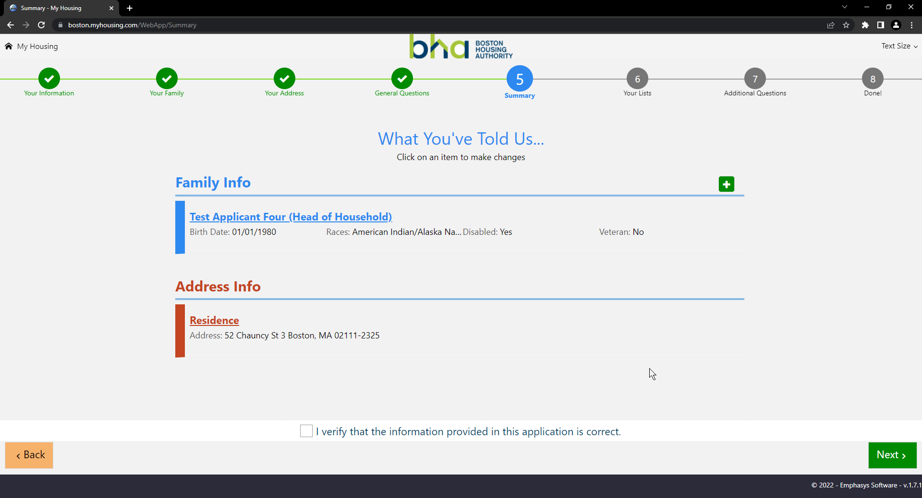

1. Click on the checkbox at the bottom to verify the information you’ve entered is correct



1. Click on Next 
2. Select the List(s) you wish to apply to by hovering over or beside the name of the list and clicking on it.
   1. Eligible lists are marked in green and show a green check when you hover over or beside the name of the list
   2. Selected lists are marked in blue and have a blue check at the right hand side
   3. Ineligible lists are marked in red and have a ‘Why?’ at the right hand side

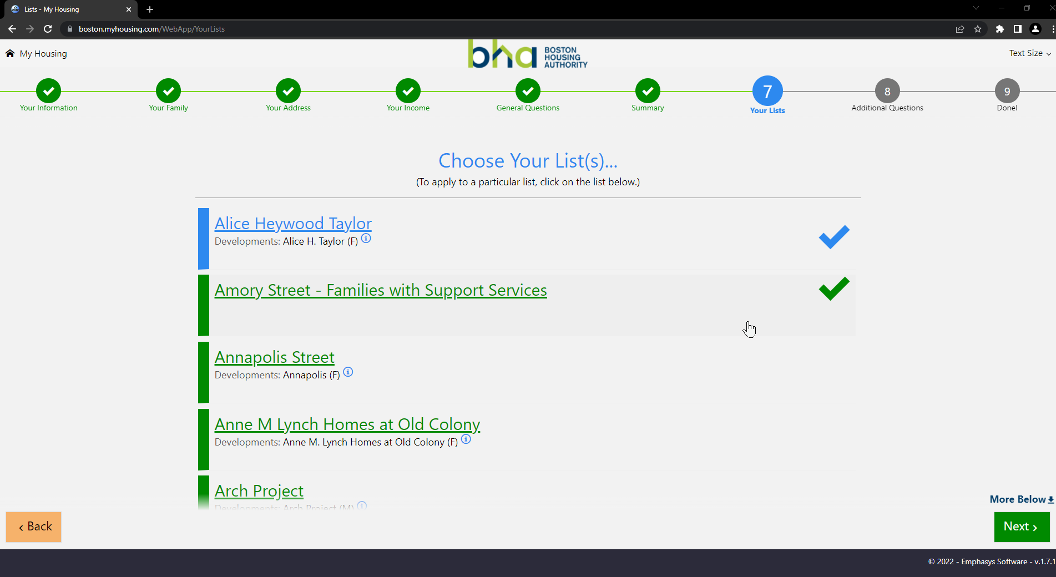

Important Note!

The lists that you do **NOT** qualify for are at the bottom of this page. Beside every list there is a link named ‘Why?’. You can click on it to know the reason why you’re not eligible for that particular list

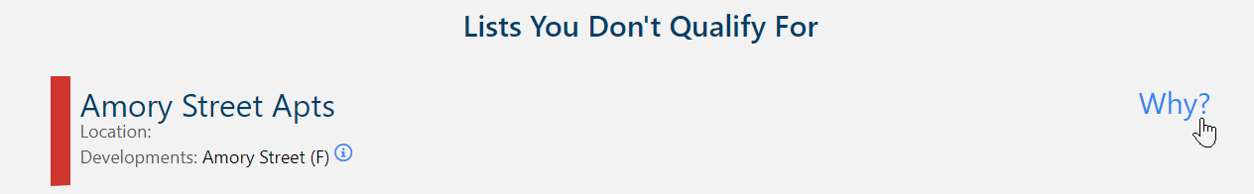



1. Click on Next  after you have selected all your lists
2. Answer **all** of the additional questions about your emergency housing situation or your preferences to get points.

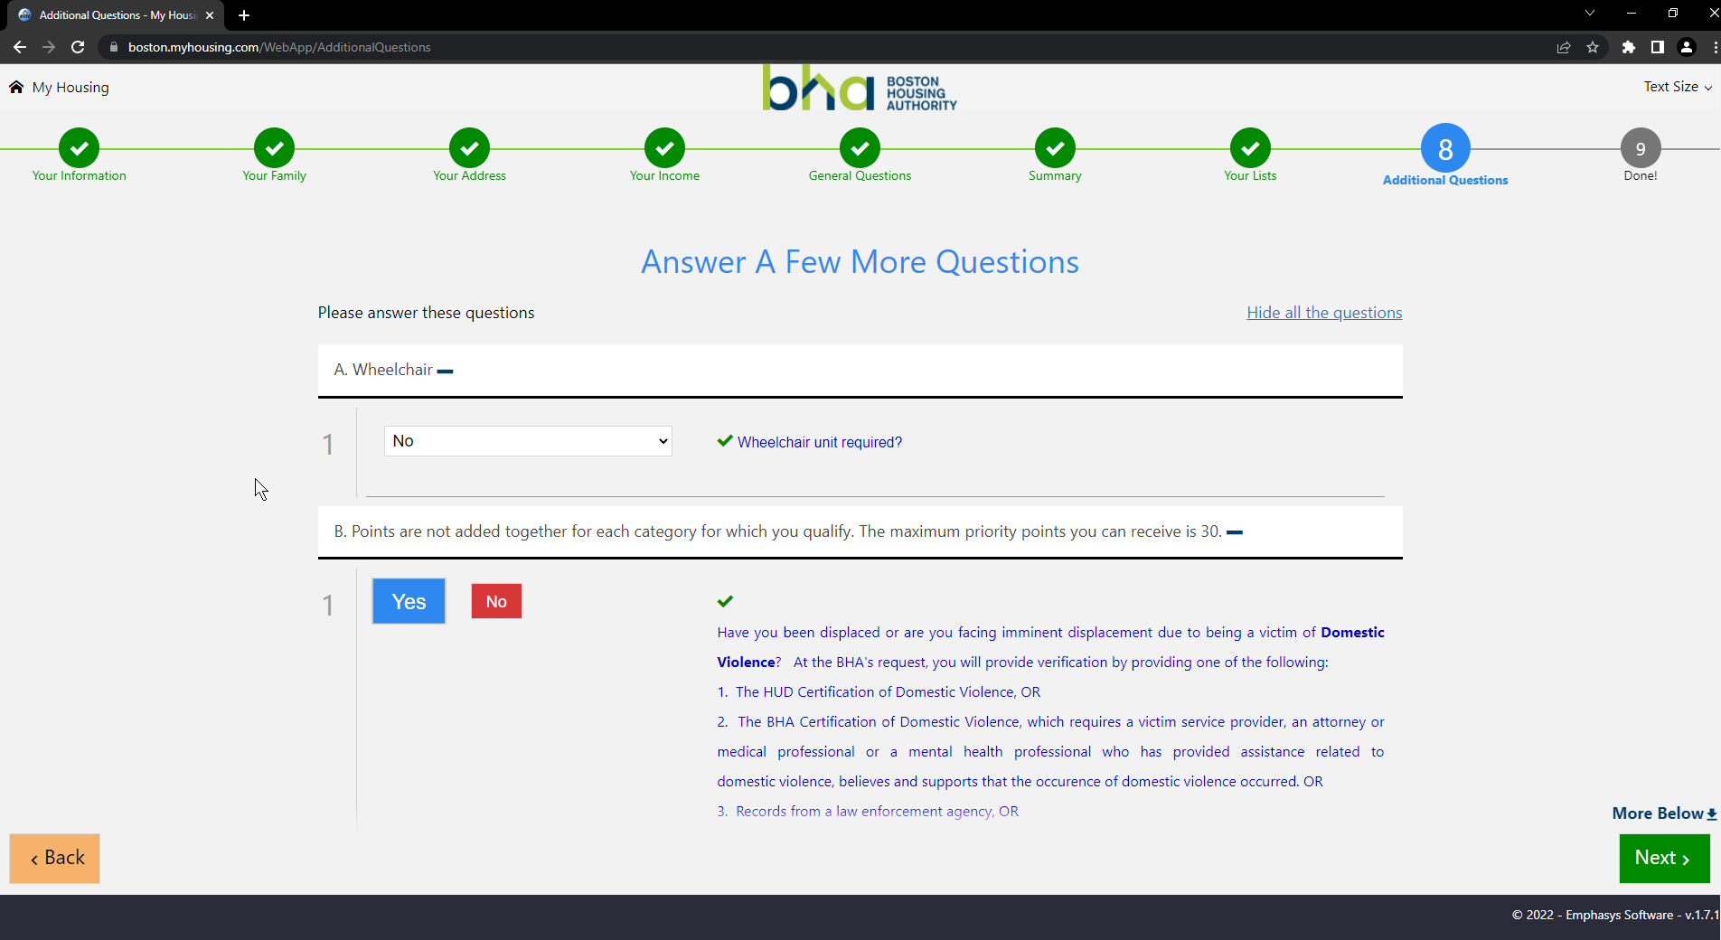

Important Note!

Points and date of application determine your position on the list

1. Click on Next  to **submit** application

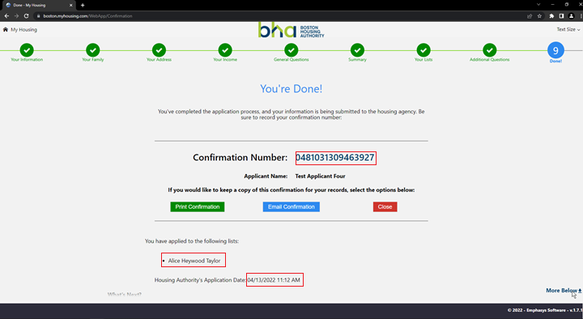

Important Note!

Please note the confirmation number, verify that the lists you applied to are present and the date and time of the application.

1. Click on Print Confirmation to save the information on this page 

- END – Applying in BHA Portal (First-time users)

### Applying in BHA Portal (returning users)

If you are a returning user i.e. if you have applied to BHA using the method above, or have a previous application with us, please follow the following steps to Register your account with us.

Important Note!

For new applicants, you need to wait till the next day before the registration is open to you.

1. Go to <https://boston.myhousing.com/Account/Login>

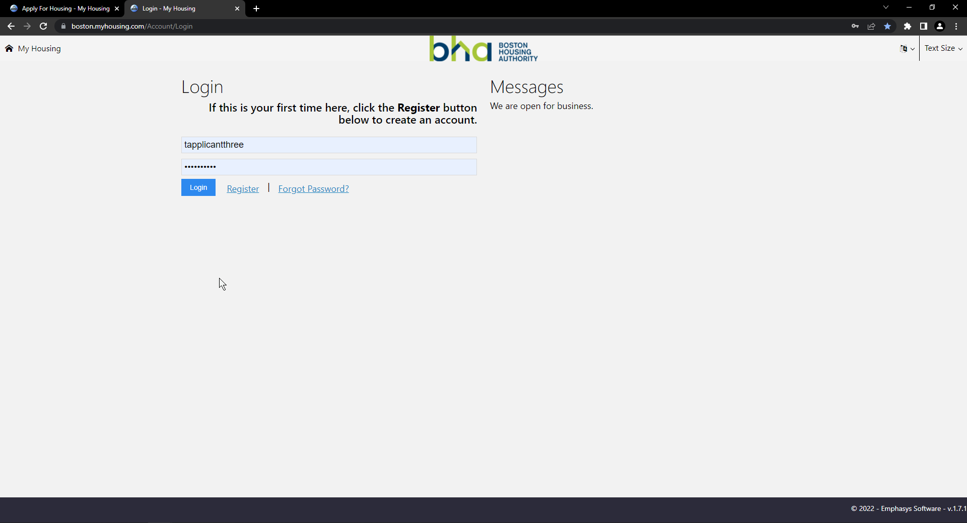

---- OR ----

Click on Already Applied  at the bottom of this page.

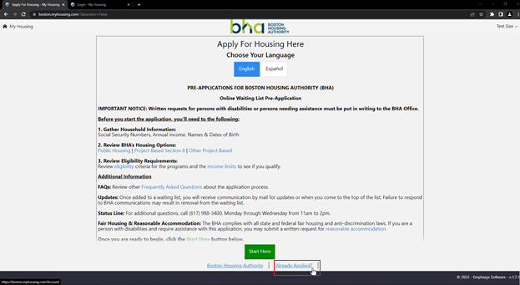

1. Click on Register 
2. Enter your information

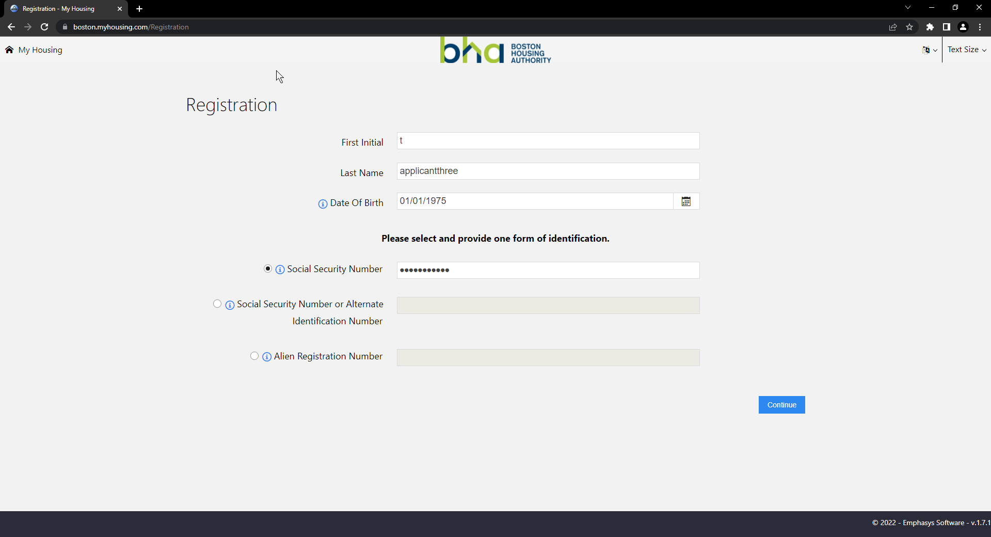

1. Make sure the information that you’re putting in is accurate and matching to our records (It should be the same information that you put in previously while applying)
2. Click on Continue 
3. Enter your information

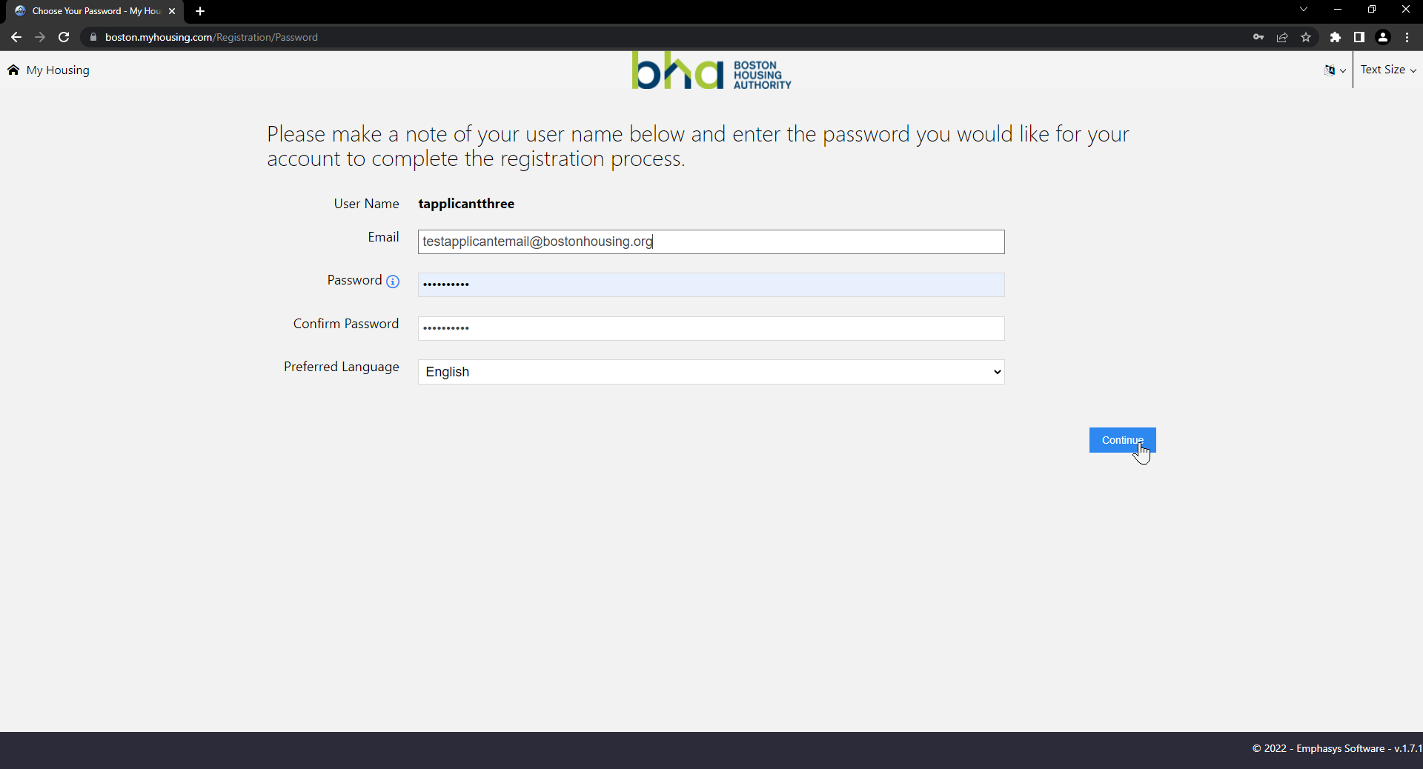

1. Make sure the email address you put in is active and working and the password you select is secure and easy for you to remember

Important Note!

The username is going to be auto-assigned to you, please make a note of this username to login

1. Click on Continue 

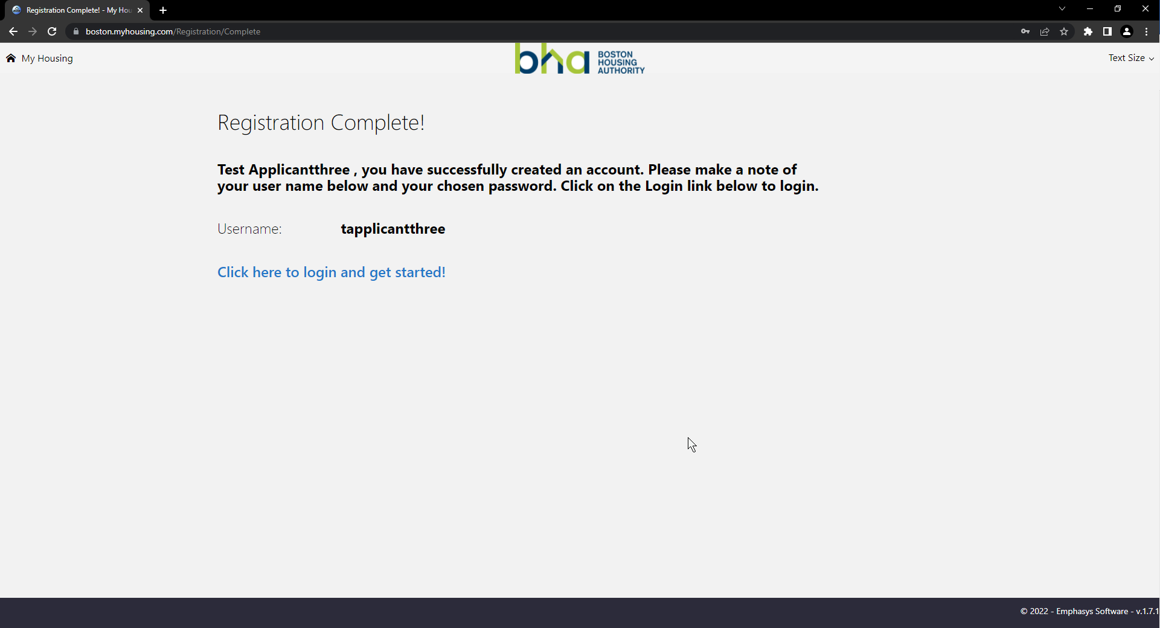

1. Click on Click here to login and get started!

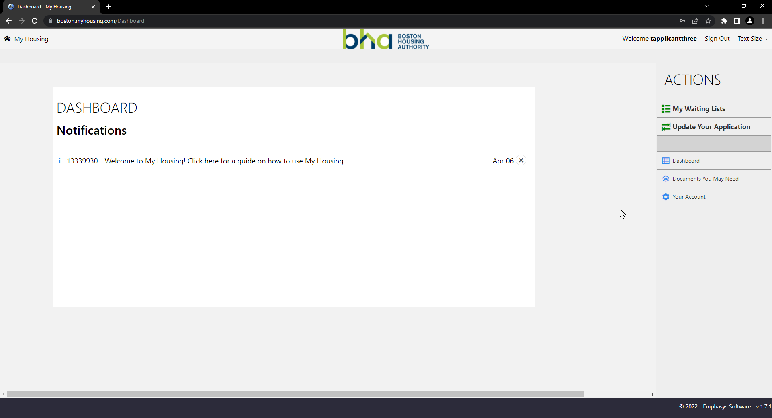

- END – Applying in BHA Portal (returning users)

### Navigating the Website/ Updating application in BHA Portal

If you are a returning user and have successfully registered your account (note the above steps to register). Use the following procedure to view your current application and make any changes to your application.

Important Note!

Upon submitting changes, you will have to wait for the Applicant Portal Specialists to approve or deny any changes that you made before being able to make further changes.

1. Go to <https://boston.myhousing.com/Account/Login>
2. Enter your credentials

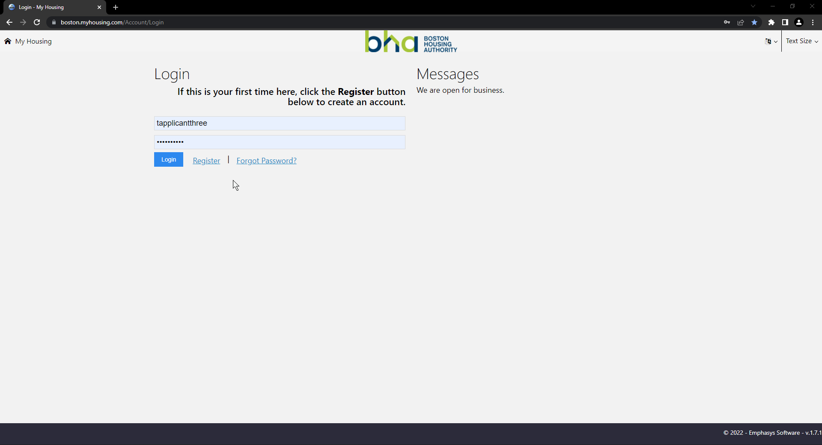

1. Click on Login 



1. Click on your notification on the dashboard for a quick guide on how to use the website
   1. Click on various action items on the list to learn about them

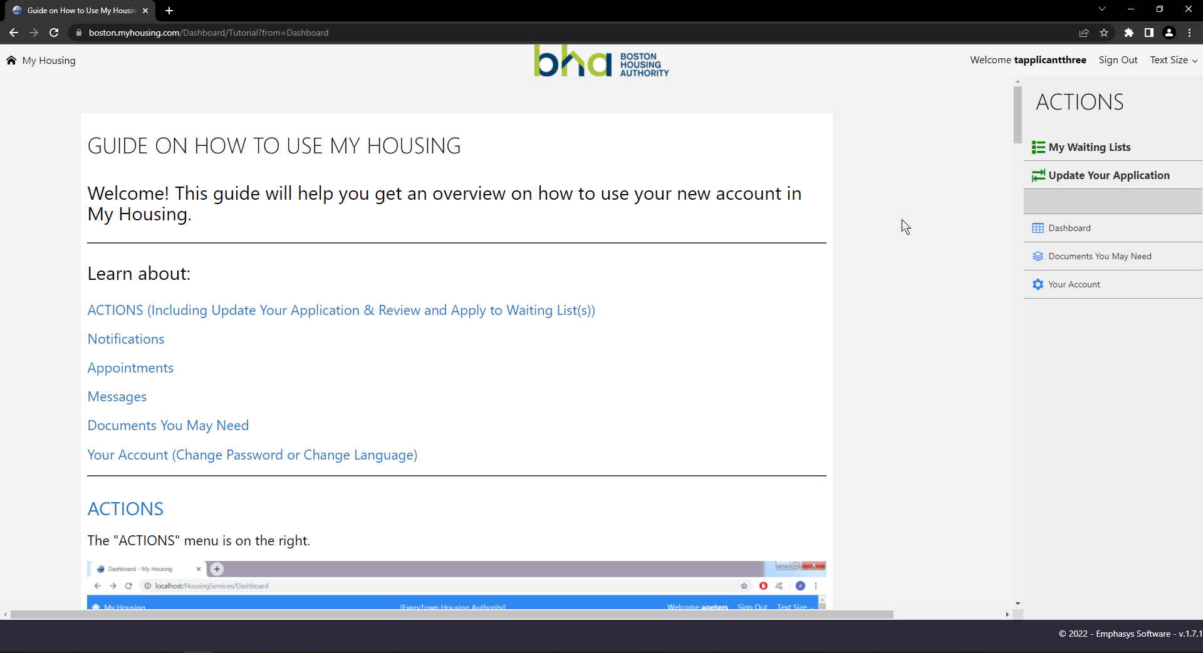

* 1. Click on the X  next to the notification to delete the notification after you have read it

Important Note!

Once deleted, a notification cannot be retrieved. Please be mindful about saving or deleting your notifications.

1. View your Waiting Lists by clicking on My Waiting Lists 
   1. You can note your application overview and your waiting lists

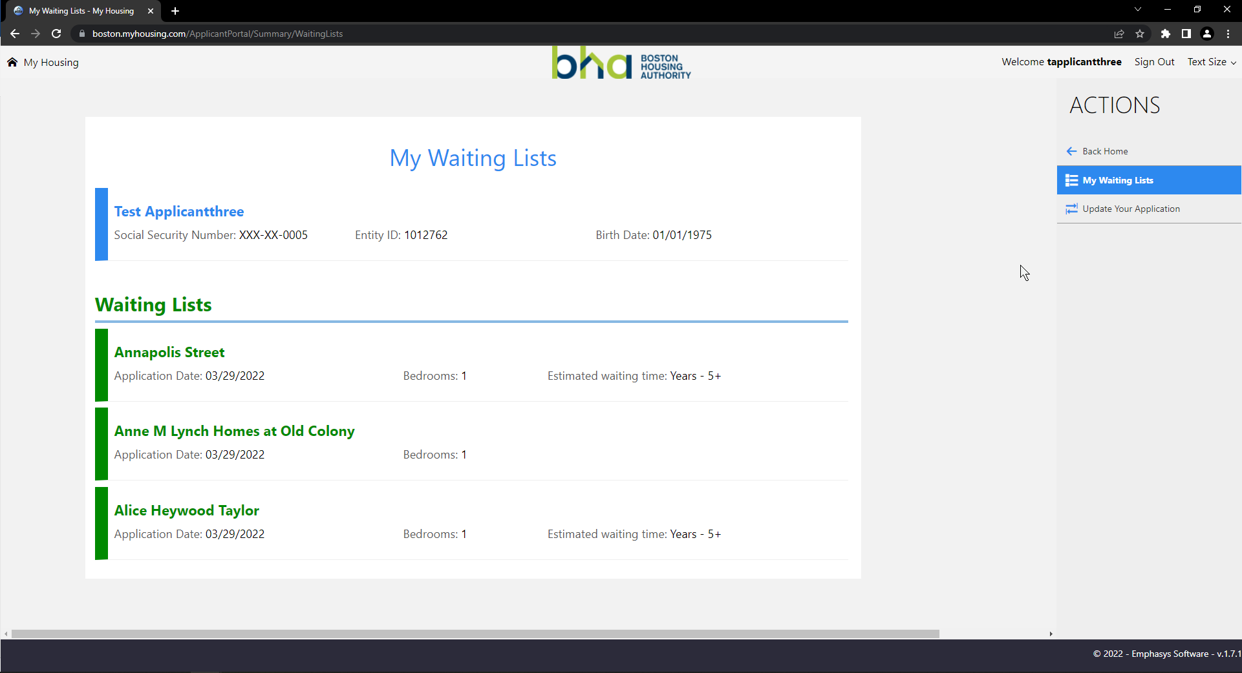

1. Click on Update your Application  to make changes or update your application

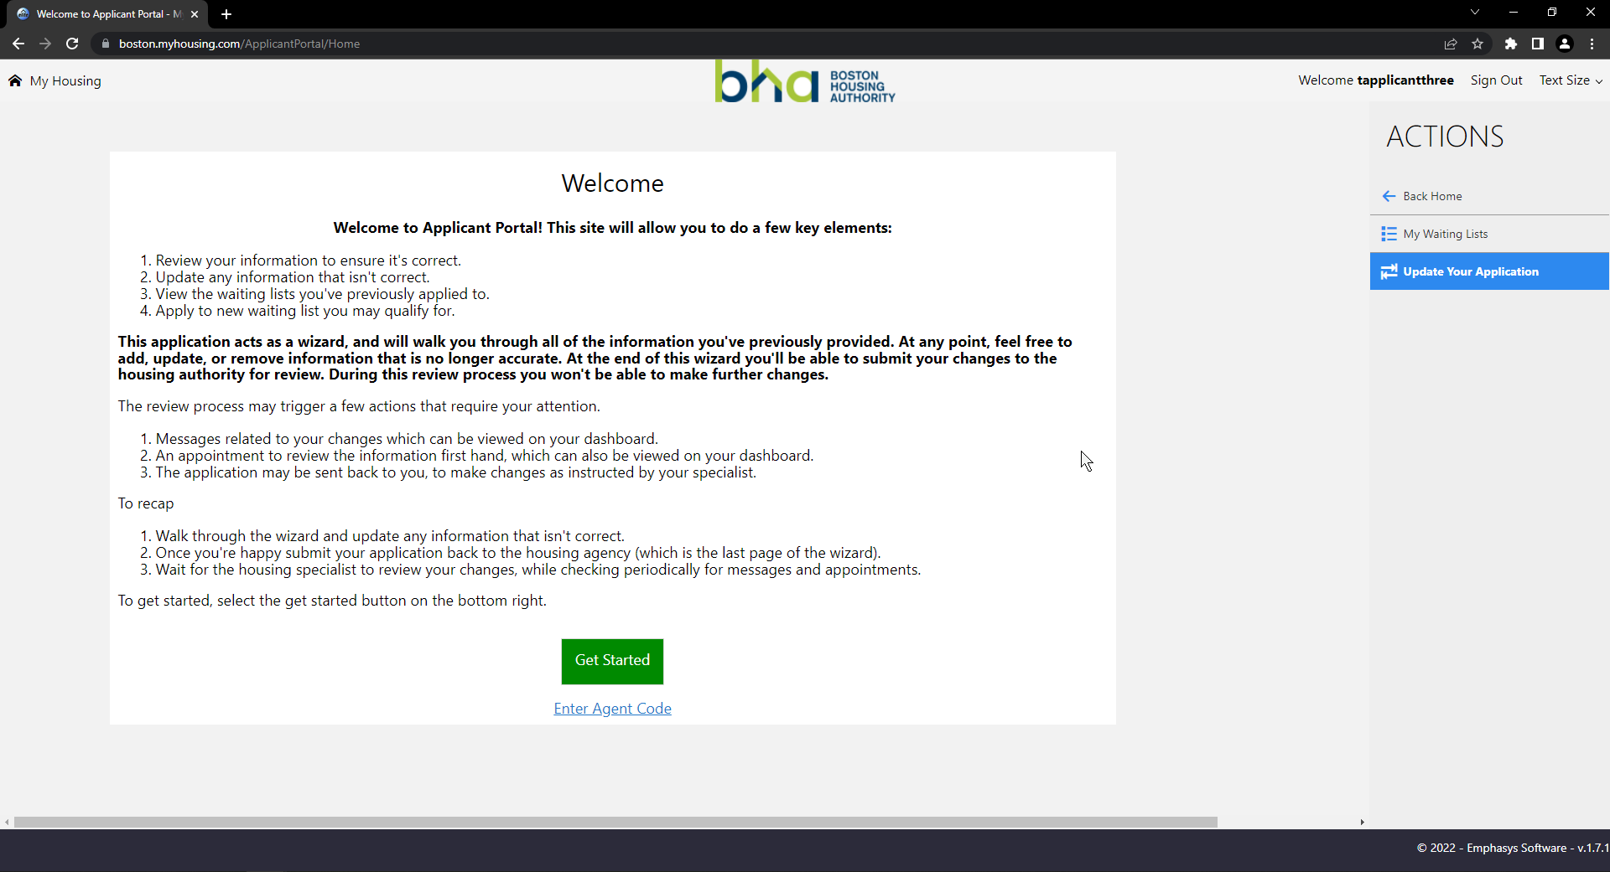

Important Note!

Please review all the information on this page prior to updating

1. Click on Get Started 
2. Verify your (Head of Household’s) information on this page

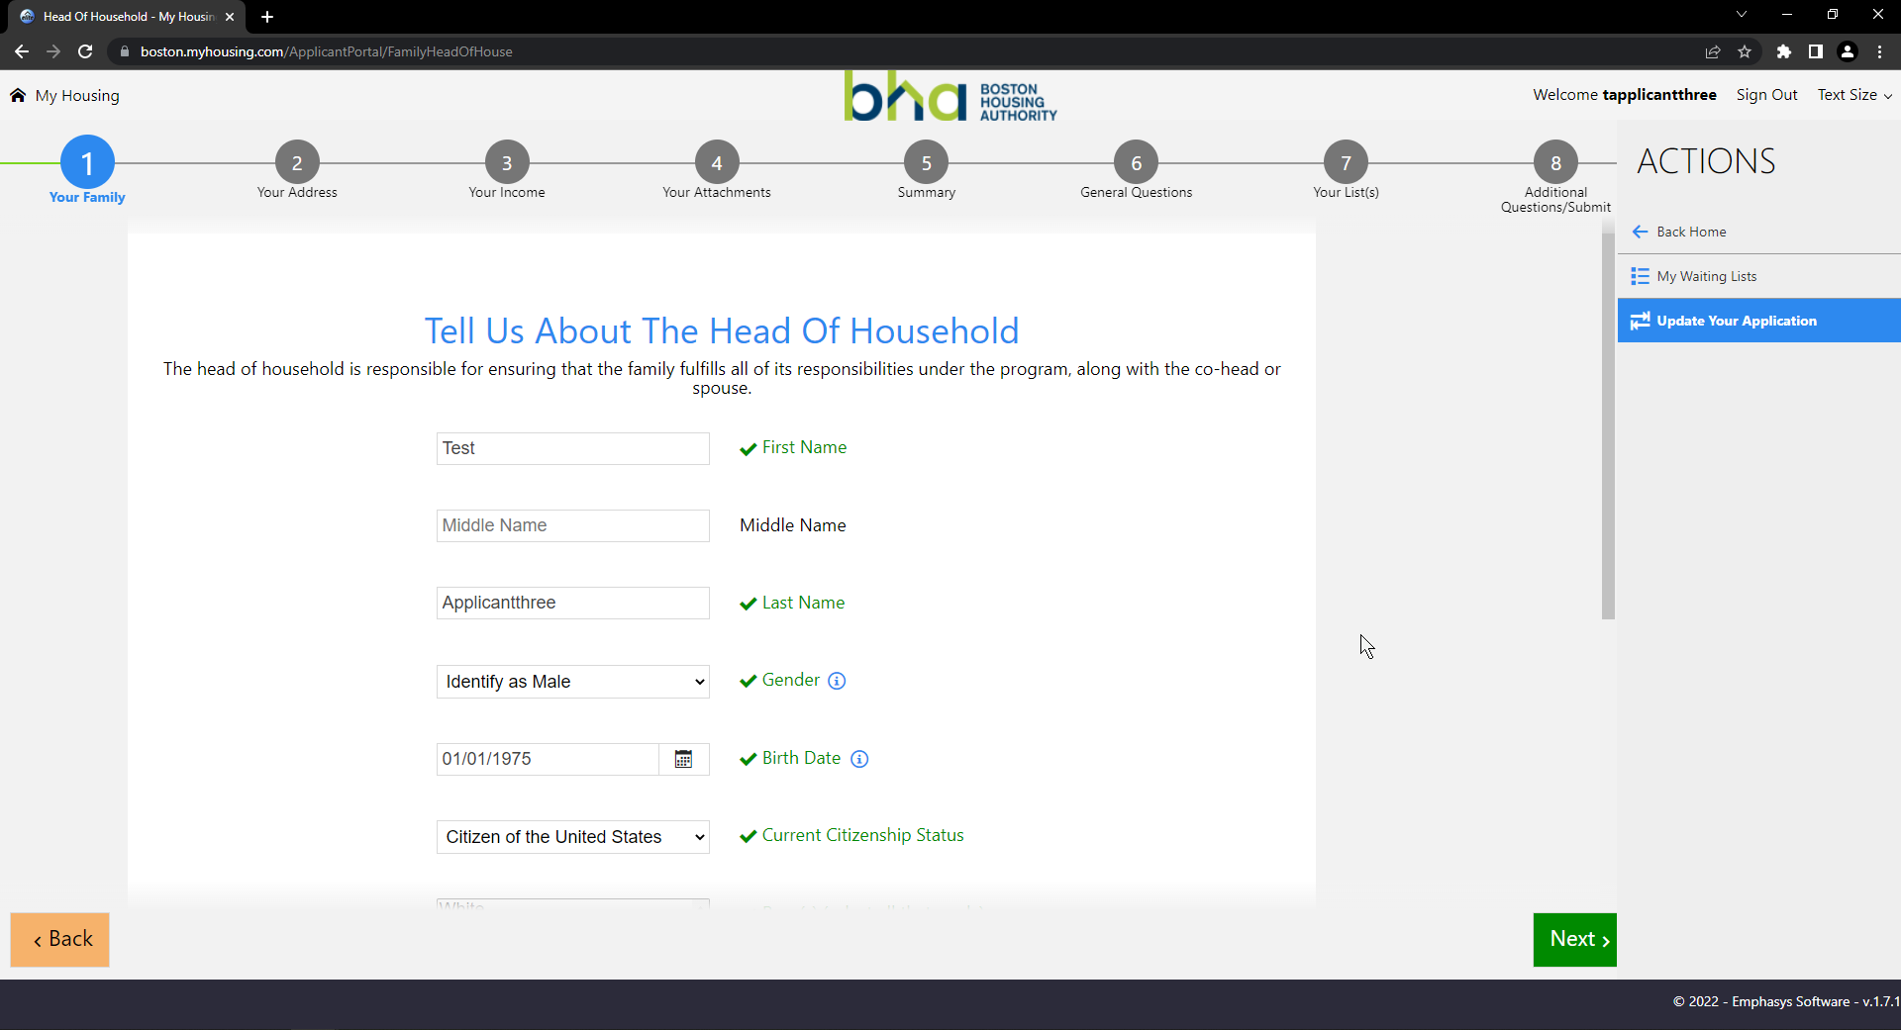

1. Make any changes if applicable
2. Click on Next 
3. If you have family members added to your application
   1. Verify your family member’s information on this page (if you have any)
   2. Each new family member’s information is located on a separate page
4. If you want to add new family members to your application
   1. Enter their information
5. If you don’t want to add any new family members,
   1. Click on Next 
6. Verify your address, make any changes if applicable

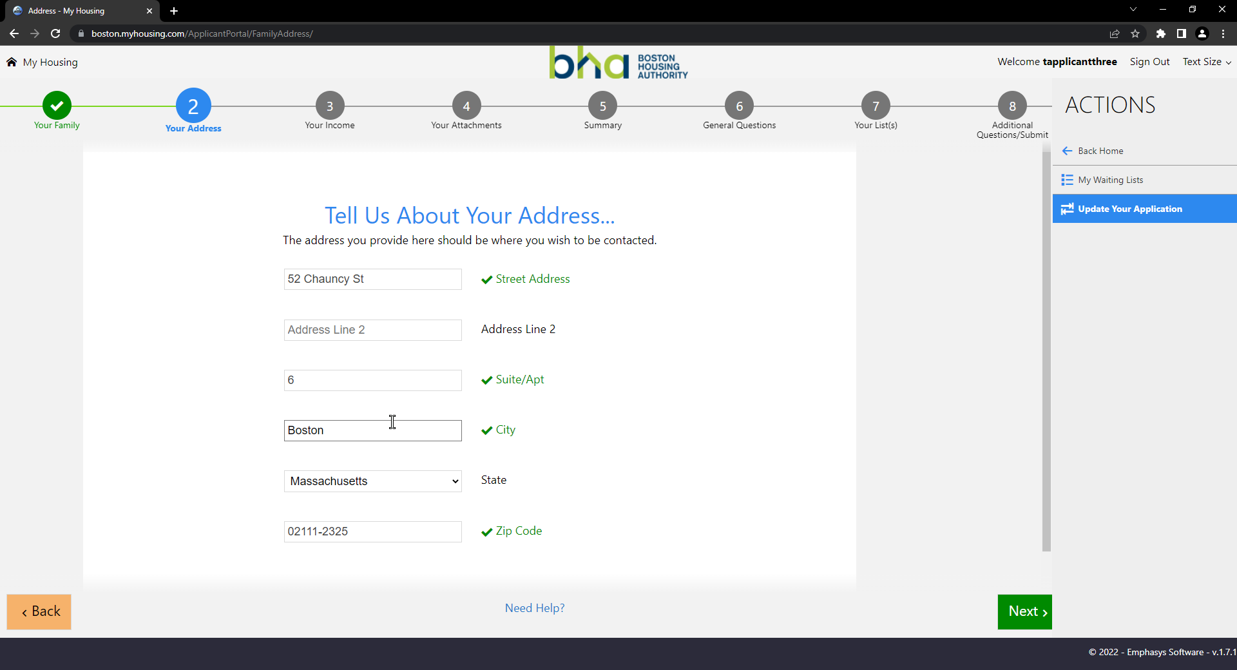

1. Click on Next 
2. Please disregard this page, do **NOT** add any information here.

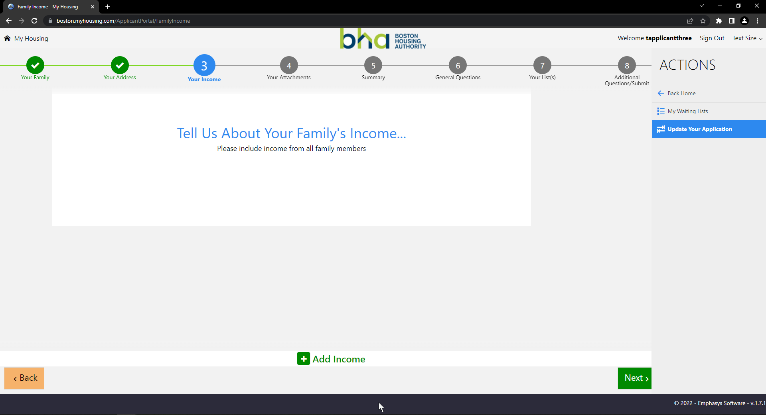

1. Click on Next 
2. Click on the checkbox at the bottom to verify the information you’ve entered is correct



1. Click on Next 
2. Answer the general questions about your eligibility

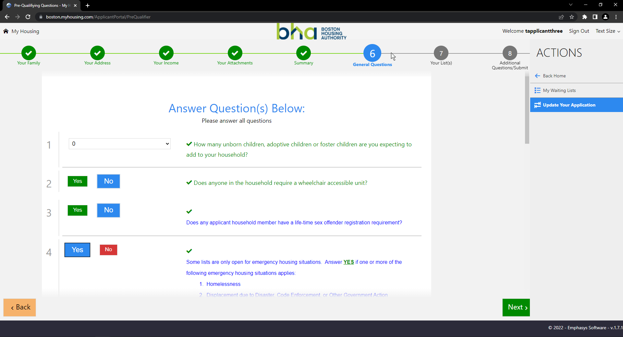

Important Note!

The information about you, your family and your answer to these questions determines your ability to apply on various BHA waiting lists. Please read all the questions carefully.

* If you qualify for “Very Low Income”, please also answer **Yes** for “Low Income” question.
* If you qualify for “Emergency Housing Situations”, please also answer **Yes** for the “Elderly or Emergency Housing Situation” question.

1. Click on Next 
2. Review the List(s) you’re currently on and Select the List(s) you wish to apply to by hovering over or beside the name of the list and clicking on it.
   1. Selected lists are marked in blue and have a blue check at the right hand side
      1. Click on Take me off this list… if you wish to remove yourself from a particular list

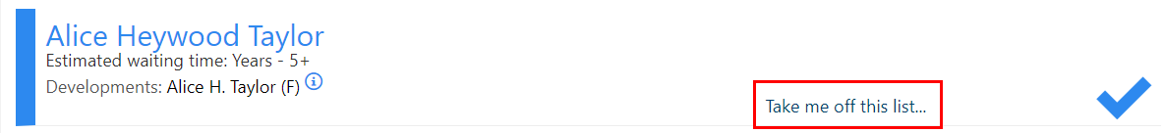

* 1. Eligible lists are marked in green and show a green check when you hover over or beside the name of the list
  2. Ineligible lists are marked in red

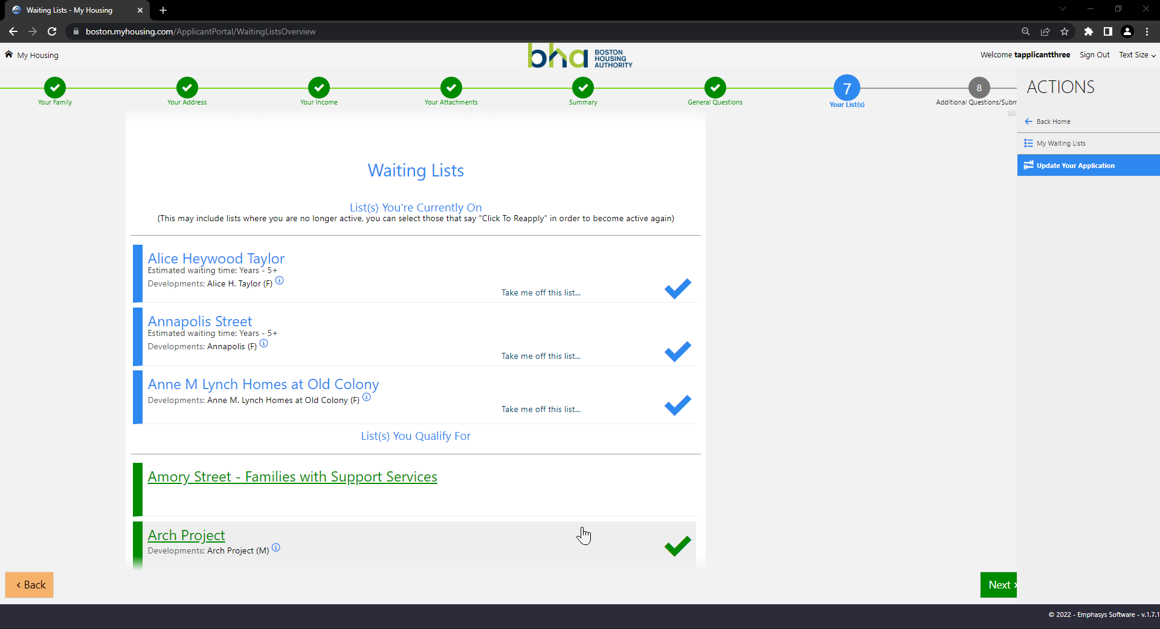

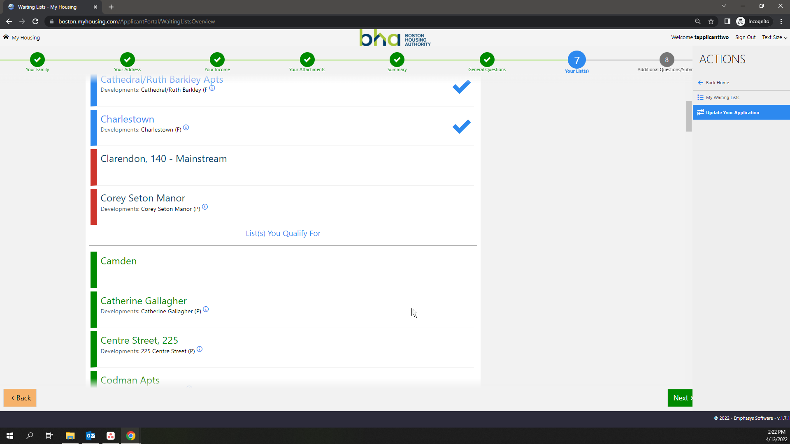

1. Click on Next 
2. Verify **all** of the additional questions about your emergency housing situation or your preferences. Change any answers which you feel are inaccurately answered.



Important Note!

Points and date of application determine your position on the list

1. Click on Submit  to **submit** application

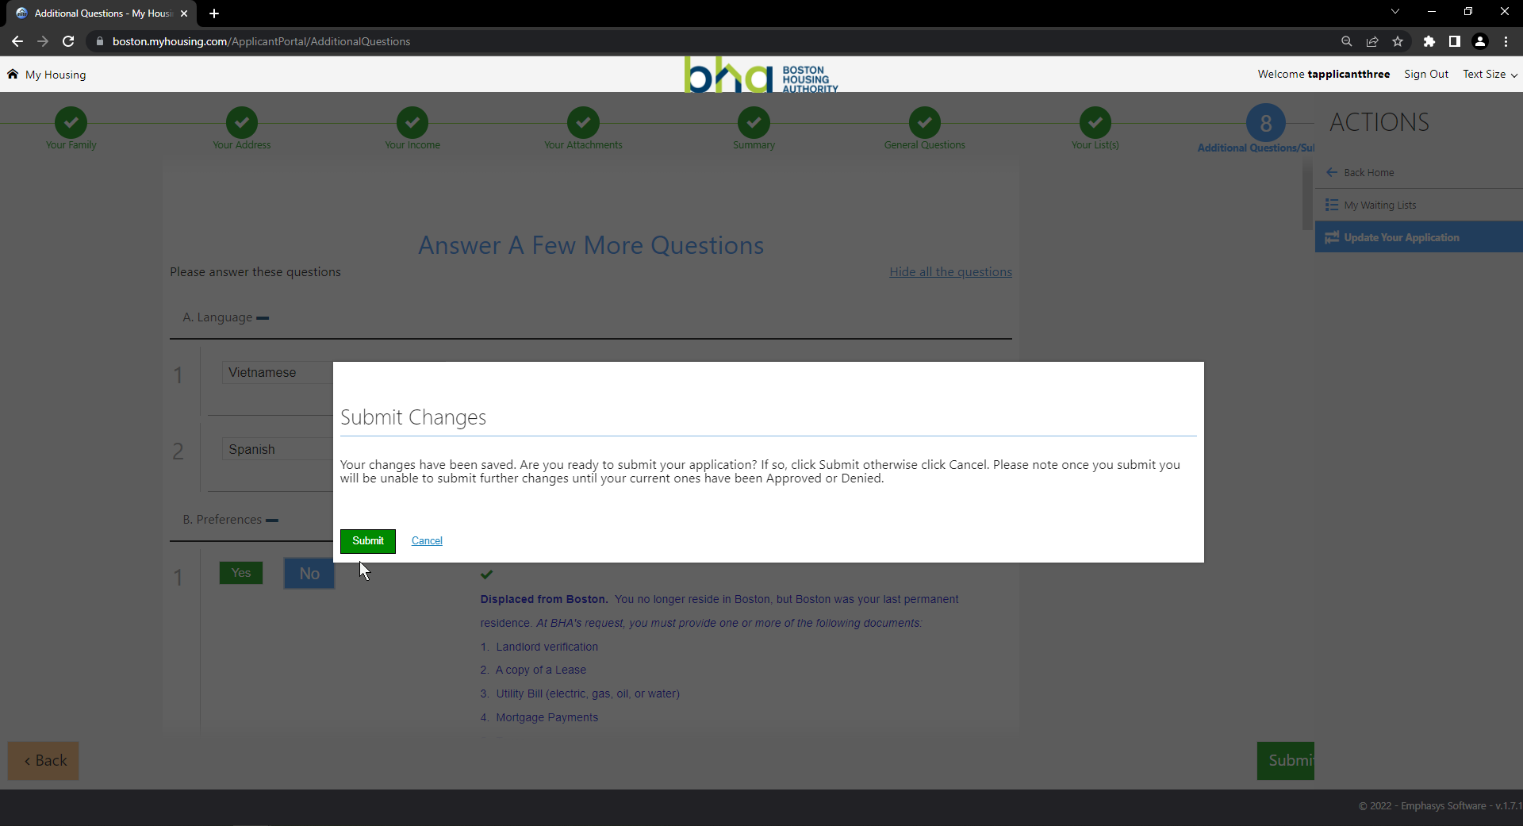

1. Click on Submit 
2. Wait for Applicant Portal Specialist to approve or deny changes made by you

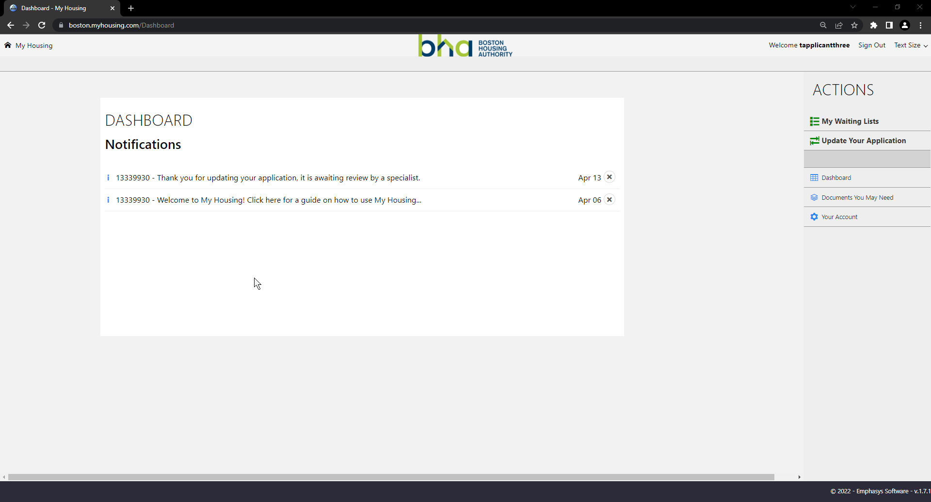

1. If your changes are denied or need more changes, you will receive a notification on your dashboard

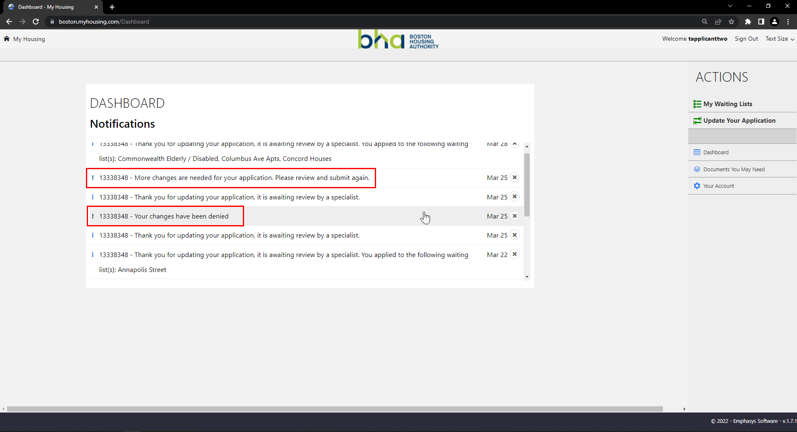

- END – Navigating the Website/ Updating application in BHA Portal